- INTRODUCTION
Renewable energy is currently widely used. One of these resources is solar energy. The photovoltaic (PV) array normally uses a maximum power point tracking (MPPT) technique to continuously deliver the highest power to the load when there are variations in irradiation and temperature. The disadvantage of PV energy is that the PV output power depends on weather conditions and cell temperature, making it an uncontrollable source. Furthermore, it is not available during the night. In order to overcome these inherent drawbacks, alternative sources, such as PEMFC, should be installed in the hybrid system. By changing the FC output power, the hybrid source output becomes controllable. However, PEMFC, in its turn, works only at a high efficiency within a specific power range (P^{low}_{FC} – P^{up}_{FC}).
The hybrid system can either be connected to the main grid or work autonomously with respect to the grid-connected mode or islanded mode, respectively. In the grid-connected mode, the hybrid source is connected to the main grid at the point of common coupling (PCC) to deliver power to the load. When load demand changes, the power supplied by the main grid and hybrid system must be properly changed.
The power delivered from the main grid and PV array as well as PEMFC must be coordinated to meet load demand. The hybrid source has two control modes: 1) unit-power control (UPC) mode and feeder-flow control (FFC) mode. In the UPC mode, variations of load demand are compensated by the main grid because the hybrid source output is regulated to reference power. Therefore, the reference value of the hybrid source output P^{ref}_{MS} must be determined. In the FFC mode, the feeder flow is regulated to a constant, the extra load demand is picked up by the hybrid source, and, hence, the feeder reference power P^{ref}_{feeder} must be known.
This operating strategy will minimize the number of operating mode changes, improve performance of the system operation, and enhance system stability.

1.1 Distributed Generation:
Distributed generation, also called on-site generation, dispersed generation, embedded generation, decentralized generation, decentralized energy or distributed energy generates electricity from many small energy sources. Currently, industrial countries generate most of their electricity in large centralized facilities, such as fossil fuel (coal, gas powered) nuclear or hydropower plants. These plants have excellent economies of scale, but usually transmit electricity long distances and negatively affect the environment.
Most plants are built this way due to a geographical and geological factors. For example, coal power plants are built away from cities to prevent their heavy air pollution from affecting the populace. In addition, such plants are often built near collieries to minimize the cost of transporting coal. Hydroelectric plants are by their nature limited to operating at sites with sufficient water flow. Most power plants are often considered to be too far away for their waste heat to be used for heating buildings.
Low pollution is a crucial advantage of combined cycle plants that burn natural gas. The low pollution permits the plants to be near enough to a city to be used for district heating and cooling.
Distributed generation is another approach. It reduces the amount of energy lost in transmitting electricity because the electricity is generated very near where it is used, perhaps even in the same building. This also reduces the size and number of power lines that must be constructed. Typical distributed power sources in a Feed-in Tariff (FIT) scheme have low maintenance, low pollution and high efficiencies. In the past, these traits required dedicated operating engineers and large complex plants to reduce pollution. However, modern embedded systems can provide these traits with automated operation and renewables, such as sunlight, wind and geothermal. This reduces the size of power plant that can show a profit.
Distributed Generation is mainly possible in an economic way if PV system or Fuel cell or any other Non-Conventional means of energy sources are available. Because it is not possible to go with Thermal power plant, Hydel power plant or any other Nuclear power plant.
1.2 Distributed Energy Systems:
Today, new advances in technology and new directions in electricity regulation encourage a significant increase of distributed generation resources around the world. As shown in Fig. the currently competitive small generation units and the incentive laws to use renewable energies force electric utility companies to construct an increasing number of distributed generation units on its distribution network, instead of large central power plants. Moreover, DES can offer improved service reliability, better economics and a reduced dependence on the local utility. Distributed Generation Systems have mainly been used as a standby power source for critical businesses. For example, most hospitals and office buildings had stand-by diesel generation as an emergency power source for use only during outages. However, the diesel generators were not inherently cost-effective, and produce noise and exhaust that would be objectionable on anything except for an emergency basis.
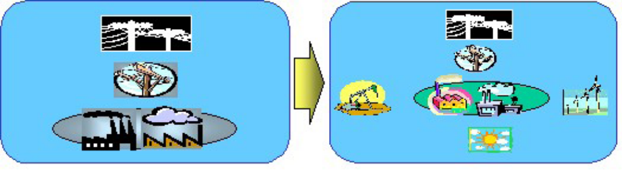
Fig.1.1: A large central power plant and distributed energy systems
The hydrogen can be supplied directly, or produced from natural gas, or liquid fuels such as alcohols, or gasoline. Each unit ranges in size from 3 – 250 kW or larger MW size. Even if they offer high efficiency and low emissions, today’s costs are high.
In the past, the electric utility industry did not offer various options that were suited for a wide range of consumer needs, and most utilities offered at best two or three combinations of reliability-price. However, the types of modern DES give commercial electric consumers various options in a wider range of reliability-price combinations. For these reasons, DES will be very likely to thrive in the next 20 years, and especially, distributed generation technologies will have a much greater market potential in areas with high electricity costs and low reliability such as in developing countries
1.3 Problem Statements:
DES technologies have very different issues compared with traditional centralized power sources. For example, they are applied to the mains or the loads with voltage of 480 volts or less; and require power converters and different strategies of control and dispatch. All of these energy technologies provide a DC output which requires power electronic interfaces with the distribution power networks and its loads. In most cases the conversion is performed by using a voltage source inverter (VSI) with a possibility of pulse width modulation (PWM) that provides fast regulation for voltage magnitude.
Power electronic interfaces introduce new control issues, but at the same time, new possibilities. For example, a system which consists of micro-generators and storage devices could be designed to operate in both an autonomous mode and connected to the power grid. One large class of problems is related to the fact that the power sources such as microturbines and fuel cell have slow response and their inertia is much less. It must be remembered that the current power systems have storage in generators’ inertia, and this may result in a slight reduction in system frequency. As these generators become more compact, the need to link them to lower network voltage is significantly increasing.
In many cases there are also major technical barriers to operating independently in a standalone AC system, or to connecting small generation systems to the electrical distribution network with lower voltage, and the recent research issues includes:
1. Control strategy to facilitate the connection of distributed generation resources to distribution networks.
2. Efficient battery control.
3. Inverter control based on only local information.
4. Synchronization with the utility mains.
5. Compensation of the reactive power and higher harmonic components.
6. Power Factor Correction.
7. System protection.
8. Load sharing.
1.4 Modeling and Control of Inverter Interfaced DG Units:
Basically each DG unit may have DC type or rectified generation unit (Fuel cell, solar cell, wind turbine, micro turbine…), storage devices, DC-DC converter, DC-AC inverter, filter, and transformer for connecting to loads or utility in order to exchange power. Model and dynamic of each of this part may have influence in system operation. But here for simplification it is considered that DC side of the units has sufficient storage and considered as a constant DC source. Hence only DC-AC inverter modeling and control investigated in this paper.
A circuit model of a three-phase DC to AC inverter with LC output filter is further described in Figure As shown in the figure, the system consists of a DC voltage source (Vdc), a three- phase PWM inverter, an output filter (Lf and C with considering parasitic resistance of filter- Rf). Sometimes a transformer may be used for stepping up the output voltage and hence Lf can be transformer inductance.
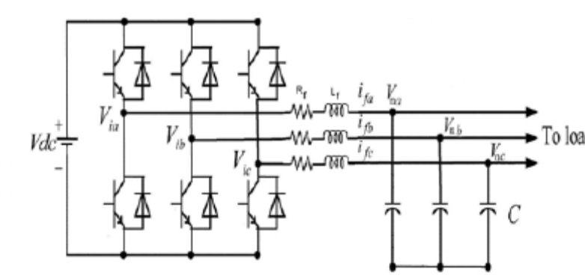
Fig. 1.2: PWM inverter diagram
There are two ways for controlling an inverter in a distributed generation system.

1.4.1 PQ Inverter Control:
This type of control is adopted when the DG unit system is connected to an external grid or to an island of loads and more generators. In this situation, the variables controlled by the inverter are the active and reactive power injected into the grid, which have to follow the set points Pref and Qref, respectively. The PQ control of an inverter can be performed using a current control technique in qd reference frame which the inverter current is controlled in amplitude and phase to meet the desired set-points of active and reactive power.
With the aim of Park transform and equations between inverter input and output, the inverter controller block diagram for supplying reference value of Pref and Qref is as figures. For the current controller, two Proportional-Integral (PI) regulators have been chosen in order to meet the requirements of stability of the system and to make the steady state error be zero. With this control scheme, it is possible to control the inverter in such way that injects reference value of Pref, Qref into other part of stand-alone network.

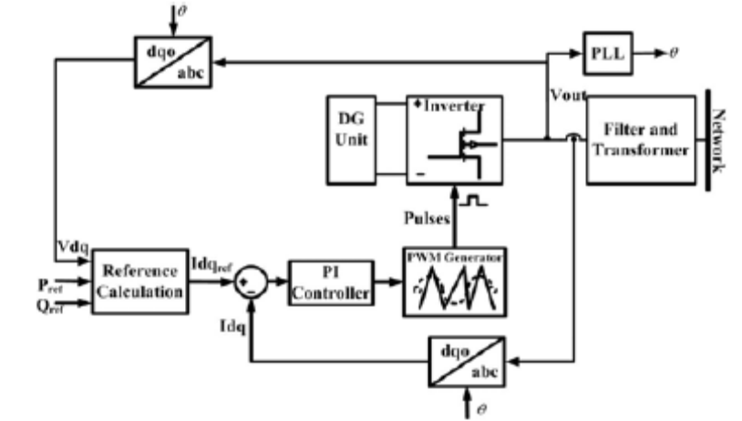
Fig. 1.3: PQ control scheme of inverter
1.4.2 V-f Inverter Control:
This controller has to act on the inverter whenever the system is in stand-alone mode of operation. In fact in this case it must regulate the voltage value at a reference bus bar and the frequency of the whole grid. A regulators work in order to keep the measured voltages upon the set points. Moreover the frequency is imposed through the modulating signals of the inverter PWM control by mean of an oscillator. A simple PI controller can regulate bus voltage in reference value with getting feedback of real bus voltage.
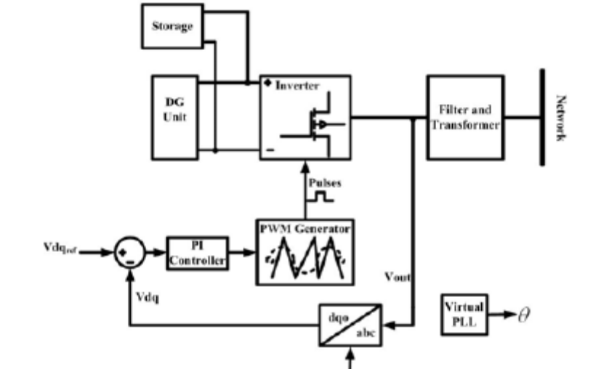
Fig. 1.4: V-f control scheme of inverter

2. Fuel cell
A fuel cell is an electrochemical cell that converts a source fuel into an electrical current. It generates electricity inside a cell through reactions between a fuel and an oxidant, triggered in the presence of an electrolyte. The reactants flow into the cell, and the reaction products flow out of it, while the electrolyte remains within it. Fuel cells can operate continuously as long as the necessary reactant and oxidant flows are maintained.
Fuel cells are different from conventional electrochemical cell batteries in that they consume reactant from an external source, which must be replenished – a thermodynamically open system. By contrast, batteries store electrical energy chemically and hence represent a thermodynamically closed system.
At the anode a catalyst oxidizes the fuel, usually hydrogen, turning the fuel into a positively charged ion and a negatively charged electron. The electrolyte is a substance specifically designed so ions can pass through it, but the electrons cannot. The freed electrons travel through a wire creating the electrical current. The ions travel through the electrolyte to the cathode. Once reaching the cathode, the ions are reunited with the electrons and the two react with a third chemical, usually oxygen, to create water or carbon dioxide.
2.1 Design Features in a Fuel Cell are:
- The electrolyte substance. The electrolyte substance usually defines the type of fuel cell.
- The fuel that is used. The most common fuel is hydrogen.
- The anode catalyst, which breaks down the fuel into electrons and ions. The anode catalyst is usually made up of very fine platinum powder.
- The cathode catalyst, which turns the ions into the waste chemicals like water or carbon dioxide. The cathode catalyst is often made up of nickel.
A typical fuel cell produces a voltage from 0.6 V to 0.7 V at full rated load. Voltage decreases as current increases, due to several factors:
- Activation loss
- Ohmic loss (voltage drop due to resistance of the cell components and interconnects)
- Mass transport loss (depletion of reactants at catalyst sites under high loads, causing rapid loss of voltage).
2.2 Types of fuel cells:

2.2.1 Proton exchange fuel cells:
In the archetypal hydrogen–oxygen proton exchange membrane fuel cell (PEMFC) design, a proton-conducting polymer membrane, (the electrolyte), separates the anode and cathode sides. This was called a "solid polymer electrolyte fuel cell" (SPEFC) in the early 1970s, before the proton exchange mechanism was well-understood. (Notice that "polymer electrolyte membrane" and "proton exchange mechanism" result in the same acronym.)
The materials used in fuel cells differ by type. In a typical membrane electrode assembly (MEA), the electrode–bipolar plates are usually made of metal, nickel or carbon nano tubes, and are coated with a catalyst (like platinum, nano iron powders or palladium) for higher efficiency. Carbon paper separates them from the electrolyte. The electrolyte could be ceramic or a membrane.
Proton exchange membrane fuel cell design issues:
- The production costs of the PEM (proton exchange membrane). The Nafion membrane currently costs $566/m². In 2005 Ballard Power Systems announced that its fuel cells will use Sholapur, a porous polyethylene film patented by DSM.
- Temperature management. The same temperature must be maintained throughout the cell in order to prevent destruction of the cell through thermal loading. This is particularly challenging as the 2H₂ + O₂ -> 2H₂O reaction is highly exothermic, so a large quantity of heat is generated within the fuel cell.
- Limited carbon monoxide tolerance of the cathode.
2.2.2 High temperature fuel cells:
2.2.2.1 A solid oxide fuel cell:
A solid oxide fuel cell (SOFC) is extremely advantageous “because of a possibility of using a wide variety of fuel” [. Unlike most other fuel cells which only use hydrogen, SOFCs can run on hydrogen, butane, methanol, and other petroleum products. The different fuels each have their own chemistry.
For methanol fuel cells, on the anode side, a catalyst breaks methanol and water down to form carbon dioxide, hydrogen ions, and free electrons. The hydrogen ions move across the electrolyte to the cathode side, where they react with oxygen to create water. A load connected externally between the anode and cathode completes the electrical circuit. Below are the chemical equations for the reaction:
Anode Reaction: CH₃OH + H₂O → CO₂ + 6H⁺ + 6e⁻
Cathode Reaction: 3/2 O₂ + 6H⁺ + 6e⁻ → 3H₂O
Overall Reaction: CH₃OH + 3/2 O₂ → CO₂ + 2H₂O + electrical energy
At the anode SOFCs can use nickel or other catalysts to break apart the methanol and create hydrogen ions and CO₂. A solid called yttrium stabilized zirconia (YSZ) is used as the electrolyte. Like all fuel cell electrolytes YSZ is conductive to ions, allowing them to pass from the anode to cathode, but is non-conductive to electrons. YSZ is a durable solid and is advantageous in large industrial systems. Although YSZ is a good ion conductor, it only works at very high temperatures.
The standard operating temperature is about 950ºC. Running the fuel cell at such a high temperature easily breaks down the methane and oxygen into ions. A major disadvantage of the SOFC, as a result of the high heat, is that it “places considerable constraints on the materials which can be used for interconnections”. Another disadvantage of running the cell at such a high temperature is that other unwanted reactions may occur inside the fuel cell. It is common for carbon dust, graphite, to build up on the anode, preventing the fuel from reaching the catalyst. Much research is currently being done to find alternatives to YSZ that will carry ions at a lower temperature.
Solid oxide fuel cells (SOFCs) offer a clean, low-pollution technology to electrochemically generate electricity at high efficiencies; since their efficiencies are not limited the way conventional heat engine's is. These fuel cells provide many advantages over traditional energy conversion systems including high efficiency, reliability, modularity, fuel adaptability, and very low levels of polluting emissions. Quiet, vibration-free operation of SOFCs also eliminates noise usually associated with conventional power generation systems.
2.2.2.2 MCFC:
Molten-carbonate fuel cells (MCFCs) are high-temperature fuel cells, that operate at temperatures of 600°C and above.
Molten carbonate fuel cells (MCFCs) are currently being developed for natural gas and coal-based power plants for electrical utility, industrial, and military applications. MCFCs are high-temperature fuel cells that use an electrolyte composed of a molten carbonate salt mixture suspended in a porous, chemically inert ceramic matrix of beta-alumina solid electrolyte (BASE). Since they operate at extremely high temperatures of 650°C (roughly 1,200°F) and above, non-precious metals can be used as catalysts at the anode and cathode, reducing costs. Improved efficiency is another reason MCFCs offer significant cost reductions over phosphoric acid fuel cells (PAFCs).
Molten carbonate fuel cells can reach efficiencies approaching 60 percent, considerably higher than the 37-42 percent efficiencies of a phosphoric acid fuel cell plant. When the waste heat is captured and used, overall fuel efficiencies can be as high as 85 percent.

Unlike alkaline, phosphoric acid, and polymer electrolyte membrane fuel cells, MCFCs don't require an external reformer to convert more energy-dense fuels to hydrogen. Due to the high temperatures at which MCFCs operate, these fuels are converted to hydrogen within the fuel cell itself by a process called internal reforming, which also reduces cost

2.3 Materials and Cell Designs:

2.3.1 Electrolyte:
Yttrium-doped zirconium oxide (YSZ) remains the most widely used material for the electrolyte in SOFCs because of its sufficient ionic conductivity, chemical stability, and mechanical strength. The only drawback of stabilized YSZ is the low ionic conductivity in the lower cell operation temperature regime, below about 750ºC (1382ºF). Two solutions that have been tried to resolve this problem are to decrease the thickness of the YSZ electrolyte and to find other materials to replace the yttrium. Scandium-doped zirconium oxide has higher conductivity than YSZ but high cost of scandium and detrimental ageing effects in scandium doped zirconium oxide make it less attractive in commercializing SOFCs. Gadolinium- or samarium-doped cerium oxide materials possess higher oxide ion conductivity compared to zirconium based materials. However, cerium oxide based materials, under reducing conditions at high temperatures, exhibit significant electronic conductivity and dimensional change.

2.3.2 Cathode:

The oxidant gas is air or oxygen at the SOFC cathode, and the electrochemical reduction of oxygen requires a series of elementary reactions and involves the transfer of multiple electrons. The SOFC cathode must meet the requirements of high catalytic activity for oxygen molecule dissociation and oxygen reduction, high electronic conductivity, chemical and dimensional stability in environments encountered during cell fabrication and cell operation, thermal expansion match with other cell components, and compatibility and minimum reactivity with the electrolyte and the interconnection.

Finally, the cathode must have a stable, porous microstructure so that gaseous oxygen can readily diffuse through the cathode to the cathode/electrolyte interface. These stringent electrochemical and mechanical requirements greatly restrict the number of suitable candidate materials. Lanthanum manganite, which, when substituted with low valence elements such as calcium or strontium, has good electronic conduction.

2.3.3 Anode:
The anode must be an excellent catalyst for the oxidation of fuel (hydrogen, carbon dioxide), stable in the reducing environment of the fuel, electronically conducting, and must have sufficient porosity to allow the transport of the fuel to and the transport of the products of fuel oxidation away from the electrolyte/anode interface where the fuel oxidation reaction takes place.
The other requirements include matching of its thermal expansion coefficient with that of the electrolyte and interconnect; integrity of porosity for gas permeation; chemical stability with the electrolyte and interconnect; and applicability to use with versatile fuels and impurities. In addition, cost effectiveness is always a factor for commercialization.
Nickel-YSZ composites are the most commonly used anode materials for SOFCs. Nickel is an excellent catalyst for fuel oxidation; however, it possesses a high thermal expansion coefficient, and exhibits coarsening of microstructure due to metal aggregation through grain growth at cell operation temperatures.
2.4 Fuel cell efficiency:
The efficiency of a fuel cell is dependent on the amount of power drawn from it. Drawing more power means drawing more current, this increases the losses in the fuel cell. As a general rule, the more power (current) drawn, the lower the efficiency. Most losses manifest themselves as a voltage drop in the cell, so the efficiency of a cell is almost proportional to its voltage. For this reason, it is common to show graphs of voltage versus current (so-called polarization curves) for fuel cells. A typical cell running at 0.7 V has an efficiency of about 50%, meaning that 50% of the energy content of the hydrogen is converted into electrical energy; the remaining 50% will be converted into heat. (Depending on the fuel cell system design, some fuel might leave the system unreacted, constituting an additional loss.)
For a hydrogen cell operating at standard conditions with no reactant leaks, the efficiency is equal to the cell voltage divided by 1.48 V, based on the enthalpy, or heating value, of the reaction. For the same cell, the second law efficiency is equal to cell voltage divided by 1.23 V. (This voltage varies with fuel used, and quality and temperature of the cell.) The difference between these numbers represents the difference between the reaction's enthalpy and Gibbs free energy. This difference always appears as heat, along with any losses in electrical conversion efficiency.
Comparing limits imposed by thermodynamics is not a good predictor of practically achievable efficiencies. Also, if propulsion is the goal, electrical output of the fuel cell has to still be converted into mechanical power with another efficiency drop.
It should be underlined that fuel cell (especially high temperature) can be used as a heat source in conventional heat engine (gas turbine system). In this case the ultra high efficiency is predicted (above 70%).

2.5 In practice:
For a fuel cell operating on air, losses due to the air supply system must also be taken into account. This refers to the pressurization of the air and dehumidifying it. This reduces the efficiency significantly and brings it near to that of a compression ignition engine. Furthermore, fuel cell efficiency decreases as load increases.
It is also important to take losses due to fuel production, transportation, and storage into account. Fuel cell vehicles running on compressed hydrogen may have a power-plant-to-wheel efficiency of 22% if the hydrogen is stored as high-pressure gas, and 17% if it is stored as liquid hydrogen.^{[29]} In addition to the production losses, over 70% of US' electricity used for hydrogen production comes from thermal power, which only has an efficiency of 33% to 48%, resulting in a net increase in carbon dioxide production by using hydrogen in vehicles[
Fuel cells cannot store energy like a battery, but in some applications, such as stand-alone power plants based on discontinuous sources such as solar or wind power, they are combined with electrolyzes and storage systems to form an energy storage system.
The overall efficiency (electricity to hydrogen and back to electricity) of such plants (known as round-trip efficiency) is between 30 and 50%, depending on conditions. While a much cheaper lead-acid battery might return about 90%, the electrolyze/fuel cell system can store indefinite quantities of hydrogen, and is therefore better suited for long-term storage.
- Fuel cell gas appliances up to 70 kW
- Installation permitting guidance for hydrogen and fuel cells stationary applications
- Standard for the installation of stationary fuel cell power systems
2.6 Fuel cell applications:
2.6.1 Power:
Fuel cells are very useful as power sources in remote locations, such as spacecraft, remote weather stations, large parks, rural locations, and in certain military applications. A fuel cell system running on hydrogen can be compact and lightweight, and have no major moving parts. Because fuel cells have no moving parts and do not involve combustion, in ideal conditions they can achieve up to 99.9999% reliability. This equates to around one minute of down time in a two year period.
Since electrolyses systems do not store fuel in themselves, but rather rely on external storage units, they can be successfully applied in large-scale energy storage, rural areas being one example. In this application, batteries would have to be largely oversized to meet the storage demand, but fuel cells only need a larger storage unit (typically cheaper than an electrochemical device).
2.6.2 Co-generation:
Micro combined heat and power (MicroCHP) systems such as home fuel cells and cogeneration for office buildings and factories are in the mass production phase. The system generates constant electric power (selling excess power back to the grid when it is not consumed), and at the same time produces hot air and water from the waste heat. MicroCHP is usually less than 5 kWe for a home fuel cell or small business.

Other applications:
- Providing power for base stations or cell sites
- Off-grid power supply
- Distributed generation
- Fork Lifts

3. HYBRID POWER SYSTEMS
Electrical energy requirements for many remote applications are too large to allow the cost-effective use of stand-alone or autonomous PV systems. In these cases, it may prove more feasible to combine several different types of power sources to form what is known as a "hybrid" system. To date, PV has been effectively combined with other types of power generators such as wind, hydro, thermoelectric, petroleum-fueled and even hydrogen. The selection process for hybrid power source types at a given site can include a combination of many factors including site topography, seasonal availability of energy sources, cost of source implementation, cost of energy storage and delivery, total site energy requirements, etc.
•Hybrid power systems use local renewable resource to provide power.
•Village hybrid power systems can range in size from small household systems (100 Wh/day) to ones supplying a whole area (10’s MWh/day).
•They combine many technologies to provide reliable power that is tailored to the local resources and community.
•Potential components include: PV, wind, micro-hydro, river-run hydro, biomass, batteries and conventional generators.
3.1 Configuration of hybrid system:
Figure shows the basic configuration of hybrid system discussed in this study. The hybrid system was consisted of reduction gear, main-motor (EM1), sub- motor (EM2), engine, power controller and battery. It was supposed that a double-motor system was prepared for the driving system discussed in this study. At first, acceleration was assisted by was applied only by main motor when the driving speed was low, while the corporation by two motors was often achieved to drive the system. If the SOC (state of charge) of battery was decreased below the specific threshold, the battery was charged by sub-motor. This operation was priority to over other actions. Figure 2 shows the modified configuration of hybrid system proposed in this study.
In the modified system, CVT was utilized to keep constant revolution numbers of the sub-motor when the sub-motor contributed to assist the system.
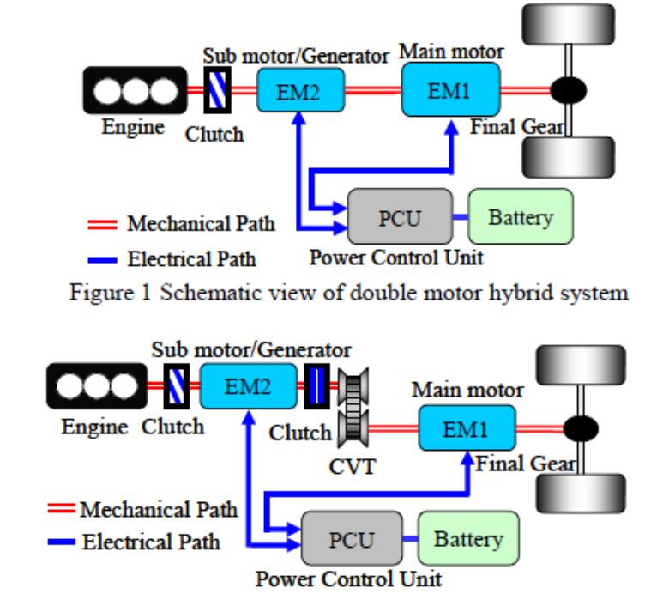
Fig 3.1: Schematic view of double motor hybrid system with CVT
3.2 Petroleum-fueled engine generators (Gensets):
Petroleum-fueled gensets (operating continuously in many cases) are presently the most common method of supplying power at sites remote from the utility grid such as villages, lodges, resorts, cottages and a variety of industrial sites including telecommunications, mining and logging camps, and military and other government operated locations. Although gensets are relatively inexpensive in initial cost, they are not inexpensive to operate. Costs for fuel and maintenance can increase exponentially when these needs must be met in a remote location. Environmental factors such as noise, carbon oxide emissions, transport and storage of fuel must also be considered.
Fuel to power conversion efficiencies may be as high as 25% (for a diesel fueled unit operating at rated capacity). Under part load conditions, however, efficiencies may decline to a few percent. Considerable waste heat is therefore available and may be utilized for other requirements such as space and/or water heating.

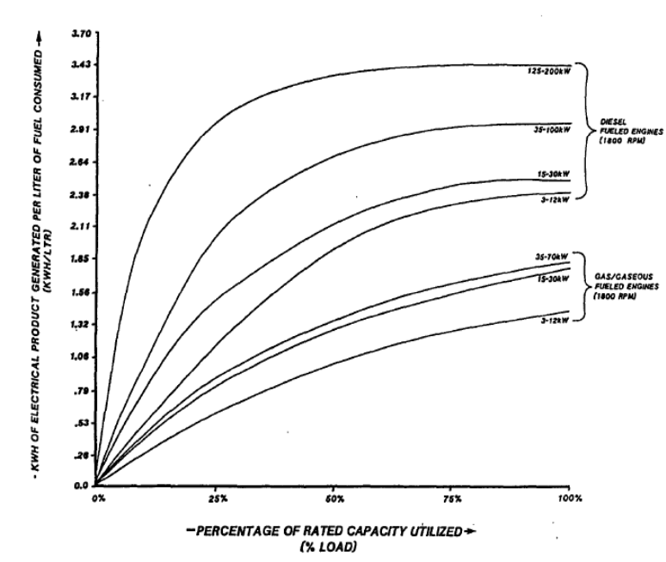
Fig 3.2 Genset fuel efficiency vs. capacity utilized
3.3 Why a PV/Genset hybrid?
PV and genset systems do not have much in common. It is precisely for this reason that they can be mated to form a hybrid system that goes far in overcoming the drawbacks to each technology. Table 10.1 lists the respective advantages and disadvantages. As the sun is a variable energy source, PV system designs are increased in size (and therefore cost) to allow for a degree of system autonomy. Autonomy is required to allow for provision of reliable power during "worst case" situations, which are usually periods of adverse weather, seasonally low solar insolation values or an unpredicted increased demand for power. The addition of autonomy to the system is accomplished by increasing the size of the PV array and its requisite energy storage system (the battery).
When a genset is added, additional battery charging and direct AC load supply capabilities are provided. The need to build in system autonomy is therefore greatly reduced. When energy demands cannot be met by the PV portion of the system for any reason, the genset is brought on line to provide the required backup power. Substantial cost savings can be achieved and overall system reliability is enhanced.
PV/genset hybrid systems have been utilized at sites with daily energy requirements ranging from as low as 1 kWh per day to as high as 1 MWh per day, which illustrates their extreme flexibility.
3.4 PV/genset hybrid system description:
The PV/genset hybrid utilizes two diverse energy sources to power a site's loads. The PV array is employed to generate DC energy that is consumed by any existing DC loads, with the balance (if any) being used to charge the system's DC energy storage battery.
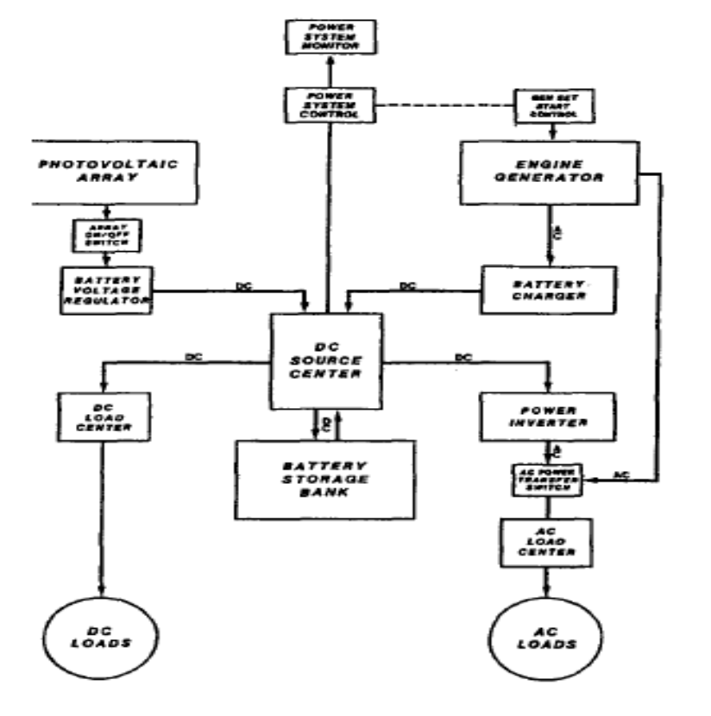
Fig 3.3 Block diagram of a hybrid PV-Genset system
The PV array is automatically on line and feeding power into the system whenever solar insolation is available and continues to produce system power during daylight hours until its rate of production exceeds what all existing DC loads and the storage battery can absorb. Should this occur, the array is inhibited by the system controller from feeding any further energy into the loads or battery.
A genset is employed to generate AC energy that is consumed by any existing AC loads, with the balance (if any) being used by the battery charger to generate DC energy that is used in the identical fashion to that described for the PV array above.
At times when the genset is not running, all site AC power is derived from the system's power conditioner or inverter, which automatically converts system DC energy into AC energy whenever AC loads are being operated. The genset is operated cyclically in direct response to the need for maintaining a suitable state of charge level in the system's battery storage bank.
3.5 Other PV/hybrid types:
Certain specific site locations may offer access to other forms of power generation. Access to flowing water presents the potential for hydro power. Access to consistent wind at sufficient velocity presents the potential for wind power. PV/hydro and PV/wind hybrid systems have been utilized at sites with daily energy requirement ranges similar to those described for PV/genset hybrids. Their use, however, is much more site dependent, as their energy source is a factor of that locations' topography.
PV/Thermoelectric generator hybrid systems have been used effectively at sites whose daily energy requirement is relatively low, ranging from 1 to 20 kWh per day. Propane is the fuel source for the thermoelectric process, and conversion efficiencies of up to 8% can be achieved. Considerable waste heat is therefore available which may be utilized for other requirements. In cold climates, this heat is often used to maintain the battery storage system at desired temperature levels.
3.6 MICROGRID CONCEPT:
To realize the emerging potential of distributed generation one must take a system approach which views generation and associated loads as a subsystem or a “microgrid”. During disturbances, the generation and corresponding loads can separate from the distribution system to isolate the microgrid’s load from the disturbance (and thereby maintaining service) without harming the transmission grid’s integrity.
The difficult task is to achieve this functionality without extensive custom engineering and still have high system reliability and generation placement flexibility. To achieve this we promote a peer-to-peer and plug-and-play model for each component of the microgrid. The peer-to-peer concept insures that there are no components, such as a master controller or central storage unit that is critical for operation of the microgrid. This implies that the microgrid can continue operating with loss of any component or generator. With one additional source (N+1) we can insure complete functionality with the loss of any source.
This ability to island generation and loads together has the potential to provide a higher local reliability than that provided by the power system as a whole. Smaller units, having power ratings in thousands of watts, can provide even higher reliability and fuel efficiency.
Also much easier to place small generators near the heat loads thereby allowing more effective use of waste heat. Basic Microgrid architecture is shown in figure 2. This consists of a group of radial feeders, which could be part of a distribution system or a building’s electrical system. There is a single point of connection to the utility called point of common coupling. Some feeders, (Feeders A-C) have sensitive loads, which require local generation.
The noncritical load feeders do not have any local generation. In our example this is Feeder D.
Feeders A-C can island from the grid using the static switch which can separate in less than a cycle. In this example there are four micro sources at nodes 8, 11, 16 and 22, which control the operation using only local voltages and currents measurements. When there is a problem with the utility supply the static switch will open, isolating the sensitive loads from the power grid. Feeder D loads ride through the event. It is assumed that there is sufficient generation to meet the loads’ demand. When the Microgrid is grid-connected power from the local generation can be directed to feeder D.

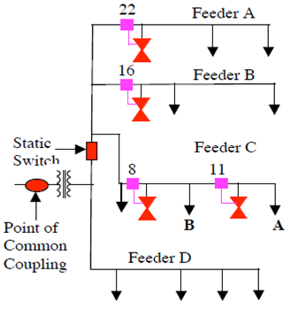
Fig 3.4: Microgrid

4. PHOTOVOLTAIC TECHNOLOGY
A PV system consists of a number of interconnected components designed to accomplish a desired task, which may be to feed electricity into the main distribution grid, to pump water from a well, to power a small calculator or one of many more possible uses of solar-generated electricity. The design of the system depends on the task it must perform and the location and other site conditions under which it must operate. This section will consider the components of a PV system, variations in design according to the purpose of the system, system sizing and aspects of system operation and maintenance.
The photovoltaic effect was first noted by a French physicist, Edmund Becquerel, in 1839, who found that certain materials would produce small amounts of electric current when exposed to light. In 1905, Albert Einstein described the nature of light and the photoelectric effect on which photovoltaic technology is based, for which he later won a Nobel prize in physics. The first photovoltaic module was built by Bell Laboratories in 1954.
It was billed as a solar battery and was mostly just a curiosity as it was too expensive to gain widespread use. In the 1960s, the space industry began to make the first serious use of the technology to provide power aboard spacecraft. Through the space programs, the technology advanced, its reliability was established, and the cost began to decline. During the energy crisis in the 1970s, photovoltaic technology gained recognition as a source of power for non-space applications.
On one side of the cell, the impurities, which are phosphorus atoms with five valence electrons (n-donor), donate weakly bound valence electrons to the silicon material, creating excess negative charge carriers. On the other side, atoms of boron with three valence electrons (p-donor) create a greater affinity than silicon to attract electrons. Because the p-type silicon is in intimate contact with the n-type silicon a p-n junction is established and a diffusion of electrons occurs from the region of high electron concentration (the n-type side) into the region of low electron concentration (p-type side).
When the electrons diffuse across the p-n junction, they recombine with holes on the p-type side. However, the diffusion of carriers does not occur indefinitely, because the imbalance of charge immediately on either sides of the junction originates an electric field. This electric field forms a diode that promotes current to flow in only one direction.
Ohmic metal-semiconductor contacts are made to both the n-type and p-type sides of the solar cell, and the electrodes are ready to be connected to an external load. When photons of light fall on the cell, they transfer their energy to the charge carriers. The electric field across the junction separates photo-generated positive charge carriers (holes) from their negative counterpart (electrons). In this way an electrical current is extracted once the circuit is closed on an external load.
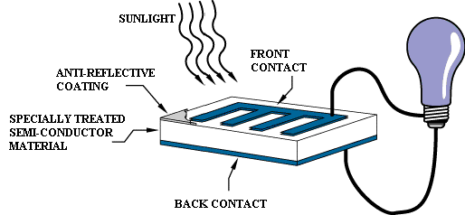
Fig 4.1: Schematic view of solar energy conducting material
4.1 Solar Cell:
The photovoltaic elect was reported by Edmund Bequerel in 1839 when he observed that the action of light on a silver coated platinum electrode immersed in electrolyte produced an electric current. Forty years later the rest solid state photovoltaic devices were constructed by workers investigating the recently discovered photoconductivity of selenium.
In 1876 William Adams and Richard Day found that a photocurrent could be produced in a sample of selenium when contacted by two heated platinum contacts. The photovoltaic action of the selenium diverted from its photoconductive action in that a current was produced spontaneously by the action of light. No external power supply was needed.
However, it was not the photovoltaic properties of materials like selenium which excited researchers, but the photoconductivity. The fact that the current produced was proportional to the intensity of the incident light, and related to the wavelength in a denite way meant that photoconductive materials were ideal for photographic light meters. It was not until the 1950s, with the development of good quality silicon wafers for applications in the new solid state electronics, that potentially useful quantities of power were produced by photovoltaic devices in crystalline silicon.
Also in 1954, a cadmium sulphide p{n junction was produced with an efficiency of 6%, and in the following years studies of p{n junction photovoltaic devices in gallium arsenide, indium phosphide and cadmium telluride were stimulated by theoretical work indicating that these materials would over a higher efficiency. However, silicon remained and remains the foremost photovoltaic material, beneting from the advances of silicon technology for the microelectronics industry. Short histories of the solar cell are given elsewhere.
During the 1990s, interest in photovoltaics expanded, along with growing awareness of the need to secure sources of electricity alternative to fossil fuels. The trend coincides with the widespread deregulation of the electricity markets and growing recognition of the viability of decentralized power. During this period, the economics of photovoltaics improved primarily through economies of scale. In the late 1990s the photovoltaic production expanded at a rate of 15{25% per annum, driving a reduction in cost.}
A number of solar cells electrically connected to each other and mounted in a single support structure or frame is called a ‘photovoltaic module’. Modules are designed to supply electricity at a certain voltage, such as a common 12 volt system. The current produced is directly dependent on the intensity of light reaching the module. Several modules can be wired together to form an array. Photovoltaic modules and arrays produce direct-current electricity. They can be connected in both series and parallel electrical arrangements to produce any required voltage and current combination.
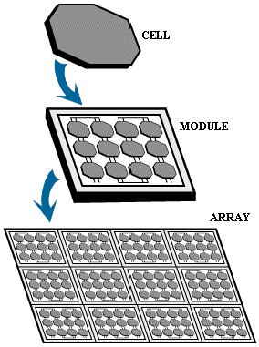
Fig 4.2: Solar Array composition
4.2 Electrical Connection of the Cells:
The electrical output of a single cell is dependent on the design of the device and the
Semi-conductor material(s) chosen, but is usually insufficient for most applications. In order to provide the appropriate quantity of electrical power, a number of cells must be electrically connected. There are two basic connection methods: series connection, in which the top contact of each cell is connected to the back contact of the next cell in the sequence, and parallel connection, in which all the top contacts are connected together, as are all the bottom contacts. In both cases, this results in just two electrical connection points for the group of cells.
- Series connection:
Figure shows the series connection of three individual cells as an example and the resultant group of connected cells is commonly referred to as a series string. The current output of the string is equivalent to the current of a single cell, but the voltage output is increased, being an addition of the voltages from all the cells in the string (i.e. in this case, the voltage output is equal to 3Vcell).
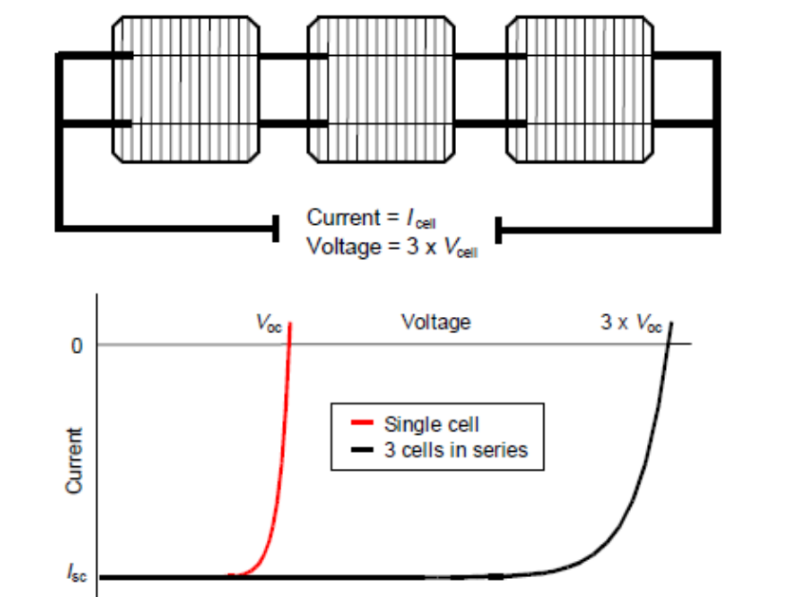
Fig 4.3: Series connection of cells, with resulting current–voltage characteristic.
It is important to have well matched cells in the series string, particularly with respect to current. If one cell produces a significantly lower current than the other cells (under the same illumination conditions), then the string will operate at that lower current level and the remaining cells will not be operating at their maximum power points.
- Parallel connection
Figure shows the parallel connection of three individual cells as an example. In this case, the current from the cell group is equivalent to the addition of the current from each cell (in this case, 3 Icell), but the voltage remains equivalent to that of a single cell.
As before, it is important to have the cells well matched in order to gain maximum output, but this time the voltage is the important parameter since all cells must be at the same operating voltage. If the voltage at the maximum power point is substantially different for one of the cells, then this will force all the cells to operate off their maximum power point, with the poorer cell being pushed towards its open-circuit voltage value and the better cells to voltages below the maximum power point voltage. In all cases, the power level will be reduced below the optimum.

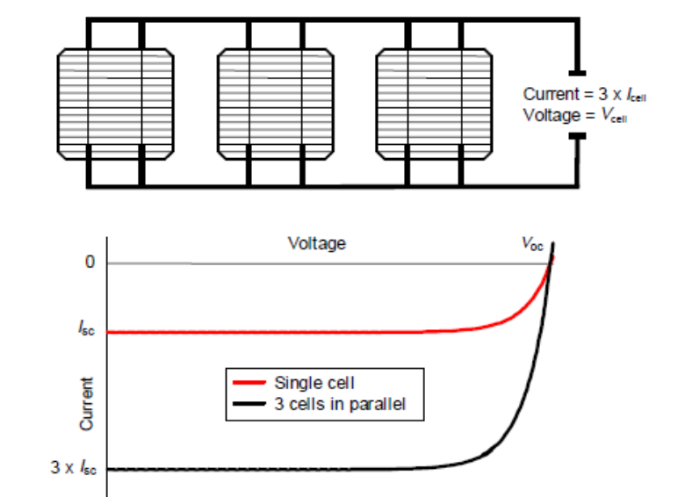
Fig. 4.4: Parallel connection of cells, with resulting current–voltage characteristic.
4.3 The Photovoltaic Array:
A PV array consists of a number of PV modules, mounted in the same plane and electrically connected to give the required electrical output for the application. The PV array can be of any size from a few hundred watts to hundreds of kilowatts, although the larger systems are often divided into several electrically independent sub arrays each feeding into their own power conditioning system.
4.3.1 Mounting Structure:
The main purpose of the mounting structure is to hold the modules in the required position without undue stress. The structure may also provide a route for the electrical wiring and may be free standing or part of another structure (e.g. a building). At its simplest, the mounting structure is a metal framework, securely fixed into the ground. It must be capable of withstanding appropriate environmental stresses, such as wind loading, for the location. As well as the mechanical issues, the mounting has an influence on the operating temperature of the system, depending on how easily heat can be dissipated by the module.
4.3.2 Tilt Angle and Orientation:
The orientation of the module with respect to the direction of the Sun determines the intensity of the sunlight falling on the module surface. Two main parameters are defined to describe this. The first is the tilt angle, which is the angle between the plane of the module and the horizontal. The second parameter is the azimuth angle, which is the angle between the plane of the module and due south (or sometimes due north depending on the definition used). Correction of the direct normal irradiance to that on any surface can be determined using the cosine of the angle between the normal to the Sun and the module plane.
The optimum array orientation will depend on the latitude of the site, prevailing weather conditions and the loads to be met. It is generally accepted that, for low latitudes, the maximum annual output is obtained when the array tilt angle is roughly equal to the latitude angle and the array faces due south (in the northern hemisphere) or due north (for the southern hemisphere). For higher latitudes, such as those in northern Europe, the maximum output is usually obtained for tilt angles of approximately the latitude angle minus 10–15 degrees. The optimum tilt angle is also affected by the proportion of diffuse radiation in the sunlight, since diffuse light is only weakly directional. Therefore, for locations with a high proportion of diffuse sunlight, the effect of tilt angle is reduced.
The calculations were carried out for the location of London using Meteonorm Version 3.0. The final aspect to consider when deciding on array orientation is the incorporation in the support structure. For building-integrated applications, the system orientation is also dictated by the nature of the roof or façade in which it is to be incorporated. It may be necessary to trade off the additional output from the optimum orientation against any additional costs that might be incurred to accomplish this. The aesthetic issues must also be considered.

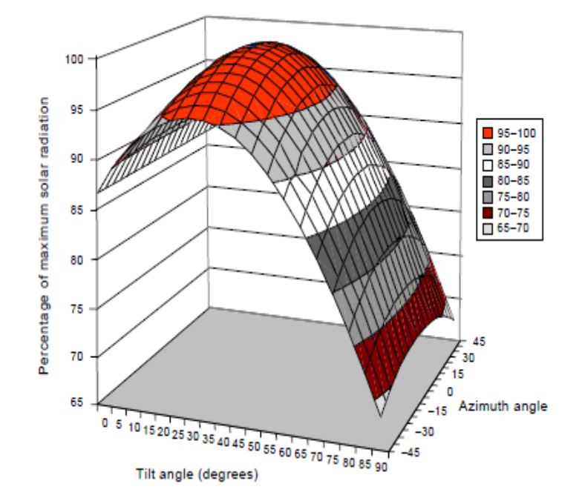
Fig. 4.5: Percentage variation of annual sunlight levels as a function of tilt angle and azimuth angle.
Figure shows the percentage variation in annual insolation levels for the location of London as tilt angle is varied between 0 and 90 degrees and azimuth angle is varied between –45o (south east) and +45o (south west).
4.4 Sun-Tracking/Concentrator Systems:
The previous section has assumed a fixed array with no change of orientation during operation. This is the usual configuration for a flat-plate array. However, some arrays are designed to track the path of the Sun. This can account fully for the sun’s movements by tracking in two axes or can account partially by tracking only in one axis, from east to west. For a flat-plate array, single-axis tracking, where the array follows the east-west movement of the Sun, has been shown to increase the output by up to 30% for a location with predominantly clear sky conditions.
Two-axis tracking, where the array follows both the daily east-west and north-south movement of the sun, could provide a further increase of about 20% (Lepley, 1990). For locations where there are frequent overcast conditions, such as northern Europe, the benefits of tracking are considerably less. It is usually more economical to install a larger panel for locations with less than about 3000 hours of direct sunshine per annum. For each case, the additional output from the system must be compared to the additional cost of including the tracking system, which includes both the control system and the mechanism for moving the array. For concentrator systems, the system must track the Sun to maintain the concentrated light falling on the cell. The accuracy of tracking, and hence the cost of the tracking system, increases as the concentration ratio increases.
4.4.1 Shading:
Shading of any part of the array will reduce its output, but this reduction will vary in magnitude depending on the electrical configuration of the array. Clearly, the output of any cell or module which is shaded will be reduced according to the reduction of light intensity falling on it. However, if this shaded cell or module is electrically connected to other cells and modules which are unshaded, their performance may also be reduced since this is essentially a mismatch situation. For example, if a single module of a series string is partially shaded, its current output will be reduced and this will then dictate the operating point of the whole string.
If several modules are shaded, the string voltage may be reduced to the point where the open-circuit voltage of that string is below the operating point of the rest of the array, and then that string will not contribute to the array output. If this is likely to occur, it is often useful to include a blocking diode for string protection, as discussed earlier.Thus, the reduction in output from shading of an array can be significantly greater than the reduction in illuminated area, since it results from:
• the loss of output from shaded cells and modules;
• the loss of output from illuminated modules in any severely shaded strings that cannot maintain operating voltage; and
• the loss of output from the remainder of the array because the strings are not operating at their individual maximum power points.
For some systems, such as those in a city environment, it may be impossible to avoid all shading without severely restricting the size of the array and hence losing output at other times. In these cases, good system design, including the optimum interconnection of modules, the use of string or module inverters and, where appropriate, the use of protection devices such as blocking diodes, can minimize the reduction in system output for the most prevalent shading conditions.
4.4.2 System design:
There are two main system configurations – stand-alone and grid-connected. As its name implies, the stand-alone PV system operates independently of any other power supply and it usually supplies electricity to a dedicated load or loads. It may include a storage facility (e.g. battery bank) to allow electricity to be provided during the night or at times of poor sunlight levels. Stand-alone systems are also often referred to as autonomous systems since their operation is independent of other power sources.
By contrast, the grid-connected PV system operates in parallel with the conventional electricity distribution system. It can be used to feed electricity into the grid distribution system or to power loads which can also be fed from the grid.
It is also possible to add one or more alternative power supplies (e.g. diesel generator, wind turbine) to the system to meet some of the load requirements. These systems are then known as ‘hybrid’ systems. Hybrid systems can be used in both stand-alone and grid-connected applications but are more common in the former because, provided the power supplies have been chosen to be complementary, they allow reduction of the storage requirement without increased loss of load probability.
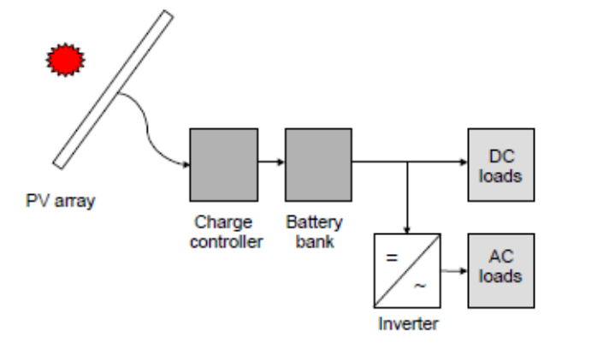
Fig. 4.6: Schematic diagram of a stand-alone photovoltaic system.

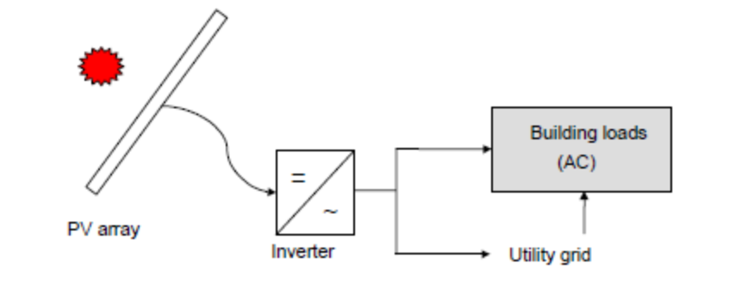
Fig. 4.7: Schematic diagram of grid-connected photovoltaic system.
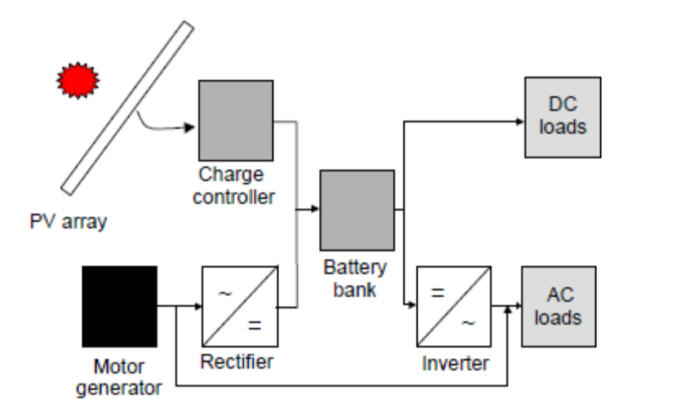
Fig. 4.8: Schematic diagram of hybrid system incorporating a photovoltaic array and a motor generator (e.g. diesel or wind).

4.5 Power Management:
Power management is one of the important features that must be considered especially in case of solar technology.
`Power management is a feature of some electrical appliances especially copiers, computers and computer peripherals such as monitors and printers, that turns off the power or switches the system to a low-power state when inactive. In computing this is known as PC power management and is built around a standard called ACPI. This supersedes APM. All recent (consumer) computers have ACPI support.
4.5.1 Motivation:
PC power management for computer systems is desired for many reasons, particularly:
- Reduce overall energy consumption
- Prolong battery life for portable and embedded systems
- Reduce cooling requirements
- Reduce noise.
- Reduce operating costs for energy and cooling.
Lower power consumption also means lower heat dissipation, which increases system stability, and less energy use, which saves money and reduces the impact on the environment.
4.6 Processor Level Techniques:
The power management for microprocessors can be done over the whole processor, or in specific areas.
With dynamic voltage scaling and dynamic frequency scaling, the CPU core voltage, clock rate, or both, can be altered to decrease power consumption at the price of potentially lower performance. This is sometimes done in real time to optimize the power-performance tradeoff.
Examples:
- AMD Cool'n'Quiet
- AMD PowerNow! ^{[1]}
- IBM EnergyScale ^{[2]}
- Intel Speed Step
- Transmeta Long Run and LongRun2
- VIA Long Haul (PowerSaver)
Additionally, processors can selectively power off internal circuitry (power gating). For example:
- Newer Intel Core processors support ultra-fine power control over the functional units within the processors.
- AMD Cool Core technology get more efficient performance by dynamically activating or turning off parts of the processor.^{[3]}
Intel VRT technology split the chip into a 3.3V I/O section and a 2.9V core section. The lower core voltage reduces power consumption.

5. MODELING OF CASE STUDY
5.1 System Description:
5.1.1 Structure of Grid-Connected Hybrid Power System:
The system consists of a PV-FC hybrid source with the main grid connecting to loads at the PCC as shown in Fig.5.1. The photovoltaic and the PEMFC are modeled as nonlinear voltage sources. These sources are connected to dc–dc converters which are coupled at the dc side of a dc/ac inverter. The dc/dc connected to the PV array works as an MPPT controller. Many MPPT algorithms have been proposed in the literature, such as incremental conductance (INC), constant voltage (CV), and perturbation and observation (P&O). The P&O method has been widely used because of its simple feedback structure and fewer measured parameters. The P&O algorithm with power feedback control is shown in Fig.5.2. As PV voltage and current are determined, the power is calculated. At the maximum power point, the derivative (dP/dV) is equal to zero. The maximum power point can be achieved by changing the reference voltage by the amount of ∆V_{ref}.
5.1.2 PV Array Model:
The mathematical model can be expressed as
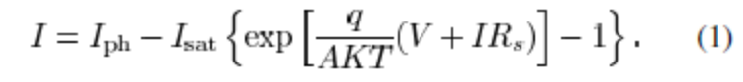
Equation (1) shows that the output characteristic of a solar cell is nonlinear and vitally affected by solar radiation, temperature, and load condition. Photocurrent I_{ph} is directly proportional to solar radiation G_{a}
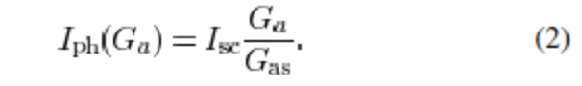
The short-circuit current of solar cell I_{sc} depends linearly on cell temperature
I_{sc}(T) = I_{scs}[1+∆I_{sc}(T-T_{s})] (3)
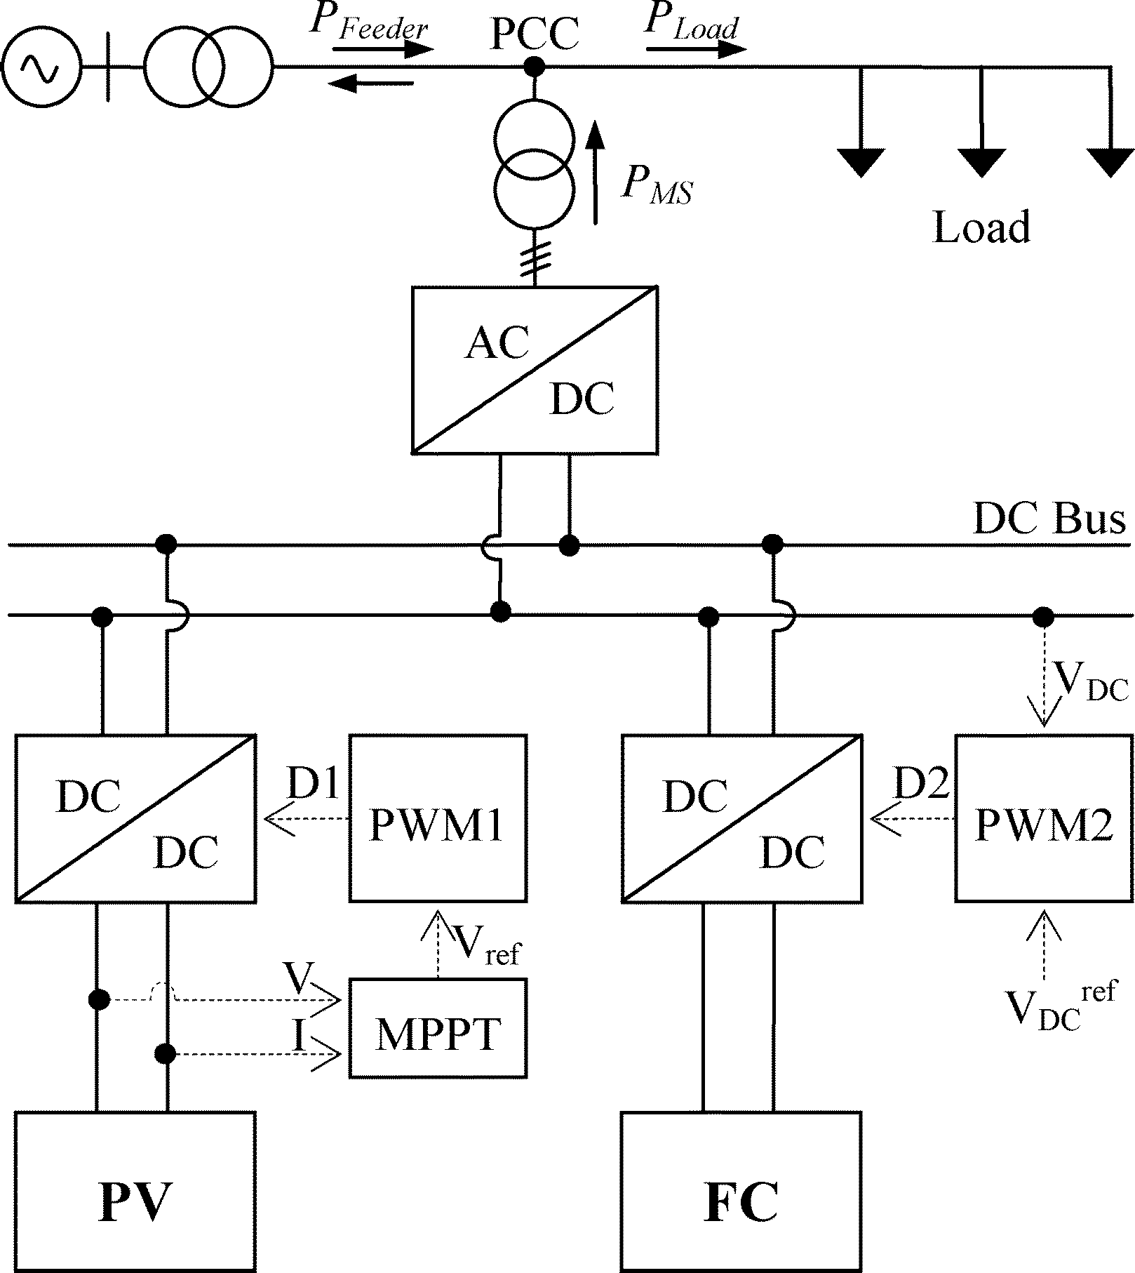

Fig.5.1. Grid-Connected PV-FC hybrid system
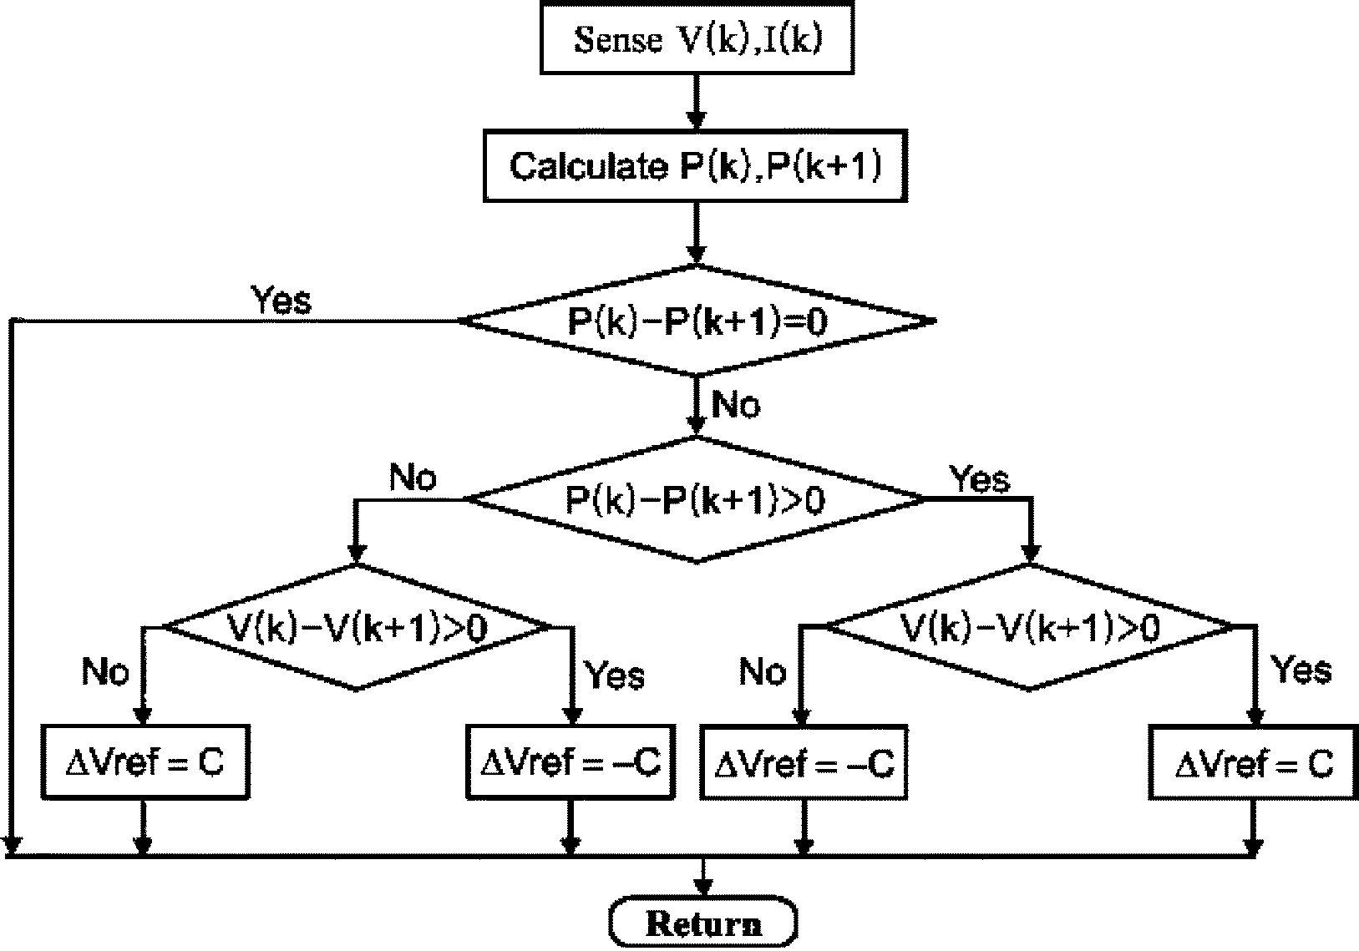
Fig.5.2. P&O MPPT algorithm
Thus, I_{ph} depends on solar irradiance and cell temperature I_{sat} also depends on solar irradiation and cell temperature and can be mathematically expressed as follows:
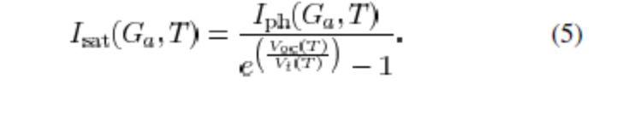

5.1.3 PEMFC Model:
The PEMFC steady-state feature of a PEMFC source is assessed by means of a polarization curve, which shows the nonlinear relationship between the voltage and current density. The
PEMFC output voltage is as follows:
V_{out} = E_{Nerst} - V_{act} - V_{ohm} - V_{conc} (6)
Where E_{Nerst} is the “thermodynamic potential” of Nerst, which represents the reversible (or open-circuit) voltage of the fuel cell.
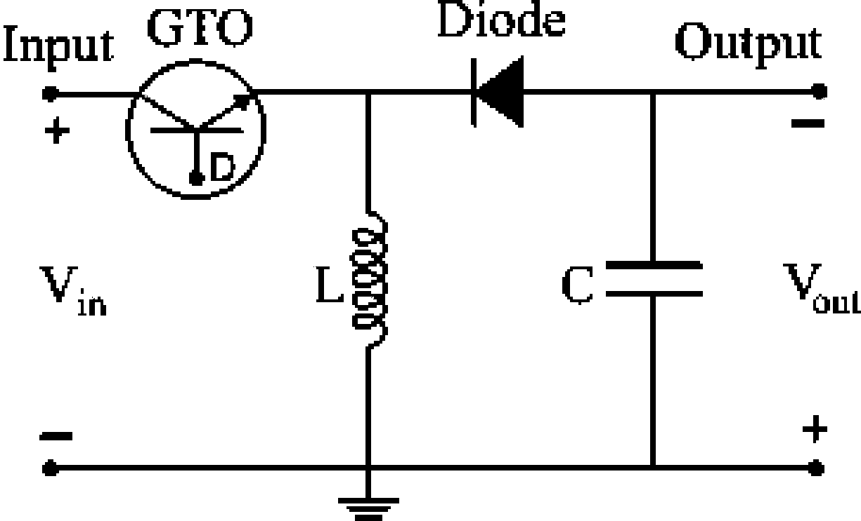
Fig.5.3. Buck Topology
Activation voltage drop V_{act} is given in the Tafel equation as
V_{act} = T [a+bln(I)] (7)
where a, b are the constant terms in the Tafel equation (in volts per Kelvin)
The overall ohmic voltage drop V_{ohm} can be expressed as
V_{ohm} = IR_{ohm} (8)
The ohmic resistance R_{ohm} of PEMFC consists of the resistance of the polymer membrane and electrodes, and the resistances of the electrodes.The concentration voltage drop V_{conc} is expressed as
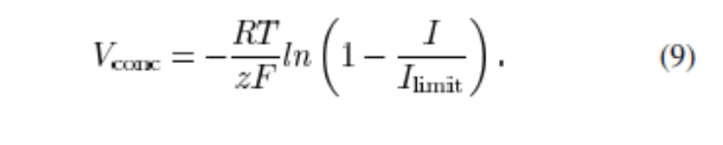
5.2 MPPT Control:
Many MPPT algorithms have been proposed in the literature, such as incremental conductance (INC), constant voltage (CV), and perturbation and observation (P&O). The two algorithms often used to achieve maximum power point tracking are the P&O and INC methods. The INC method offers good performance under rapidly changing atmospheric conditions. However, four sensors are required to perform the computations. If the sensors require more conversion time, then the MPPT process will take longer to track the maximum power point. During tracking time, the PV output is less than its maximum power. This means that the longer the conversion time is, the larger amount of power loss will be. On the contrary, if the execution speed of the P&O method increases, then the system loss will decrease.
Moreover, this method only requires two sensors, which results in a reduction of hardware requirements and cost. Therefore, the P&O method is used to control the MPPT process. In order to achieve maximum power, two different applied control methods that are often chosen are voltage-feedback control and power-feedback control. Voltage-feedback control uses the solar-array terminal voltage to control and keep the array operating near its maximum power point by regulating the array’s voltage and matching the voltage of the array to a desired voltage. The drawback of the voltage-feedback control is its neglect of the effect of irradiation and cell temperature. Therefore, the power-feedback control is used to achieve maximum power.
The P&O MPPT algorithm with a power-feedback control is shown in Fig.5.2. As PV voltage and current are determined, the power is calculated. At the maximum power point, the derivative (dP/dV) is equal to zero. The maximum power point can be achieved by changing the reference voltage by the amount of ∆V_{ref} .
In order to implement the MPPT algorithm, a buck-boost dc/dc converter is used as depicted in Fig. 5.3. The parameters L and C in the buck-boost converter must satisfy the following conditions:
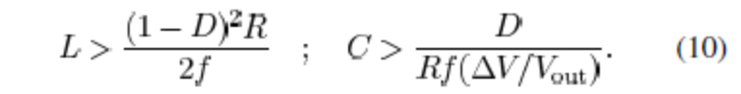
The buck-boost converter consists of one switching device (GTO) that enables it to turn on and off depending on the applied gate signal D. The gate signal for the GTO can be obtained by comparing the saw tooth waveform with the control voltage.
The change of the reference voltage ∆V_{ref} obtained by MPPT algorithm becomes the input of the pulse width modulation (PWM).
The PWM generates a gate signal to control the buck-boost converter and, thus, maximum power is tracked and delivered to the ac side via a dc/ac inverter.
5.3 Control of the Hybrid System:
The control modes in the microgrid include unit power control, feeder flow control, and mixed control mode. The two control modes were first proposed by Lasserter. In the UPC mode, the DGs (the hybrid source in this system) regulate the voltage magnitude at the connection point and the power that source is injecting. In this mode if a load increases anywhere in the microgrid, the extra power comes from the grid, since the hybrid source regulates to a constant power. In the FFC mode, the DGs regulate the voltage magnitude at the connection point and the power that is flowing in the feeder at connection point P_{Feeder.} With this control mode, extra load demands are picked up by the DGs, which maintain a constant load from the utility viewpoint.
In the mixed control mode, the same DG could control either its output power or the feeder flow power. In other words, the mixed control mode is a coordination of the UPC mode and the FFC mode. Both of these concepts were considered. In this paper, a coordination of the UPC mode and the FFC mode was investigated to determine when each of the two control modes was applied and to determine a reference value for each mode.
Moreover, in the hybrid system, the PV and PEMFC sources have their constraints. Therefore, the reference power must be set at an appropriate value so that the constraints of these sources are satisfied.
The proposed operation strategy presented in the next section is also based on the minimization of mode change. This proposed operating strategy will be able to improve performance of the system’s operation and enhance system stability.
5.4 Operating Strategy of the Hybrid System:
As mentioned before, the purpose of the operating algorithm is to determine the control mode of the hybrid source and the reference value for each control mode so that the PV is able to work at maximum output power and the constraints (P^{low}_{FC,} P^{up}_{FC,} and P^{max}_{FC}) are fulfilled.
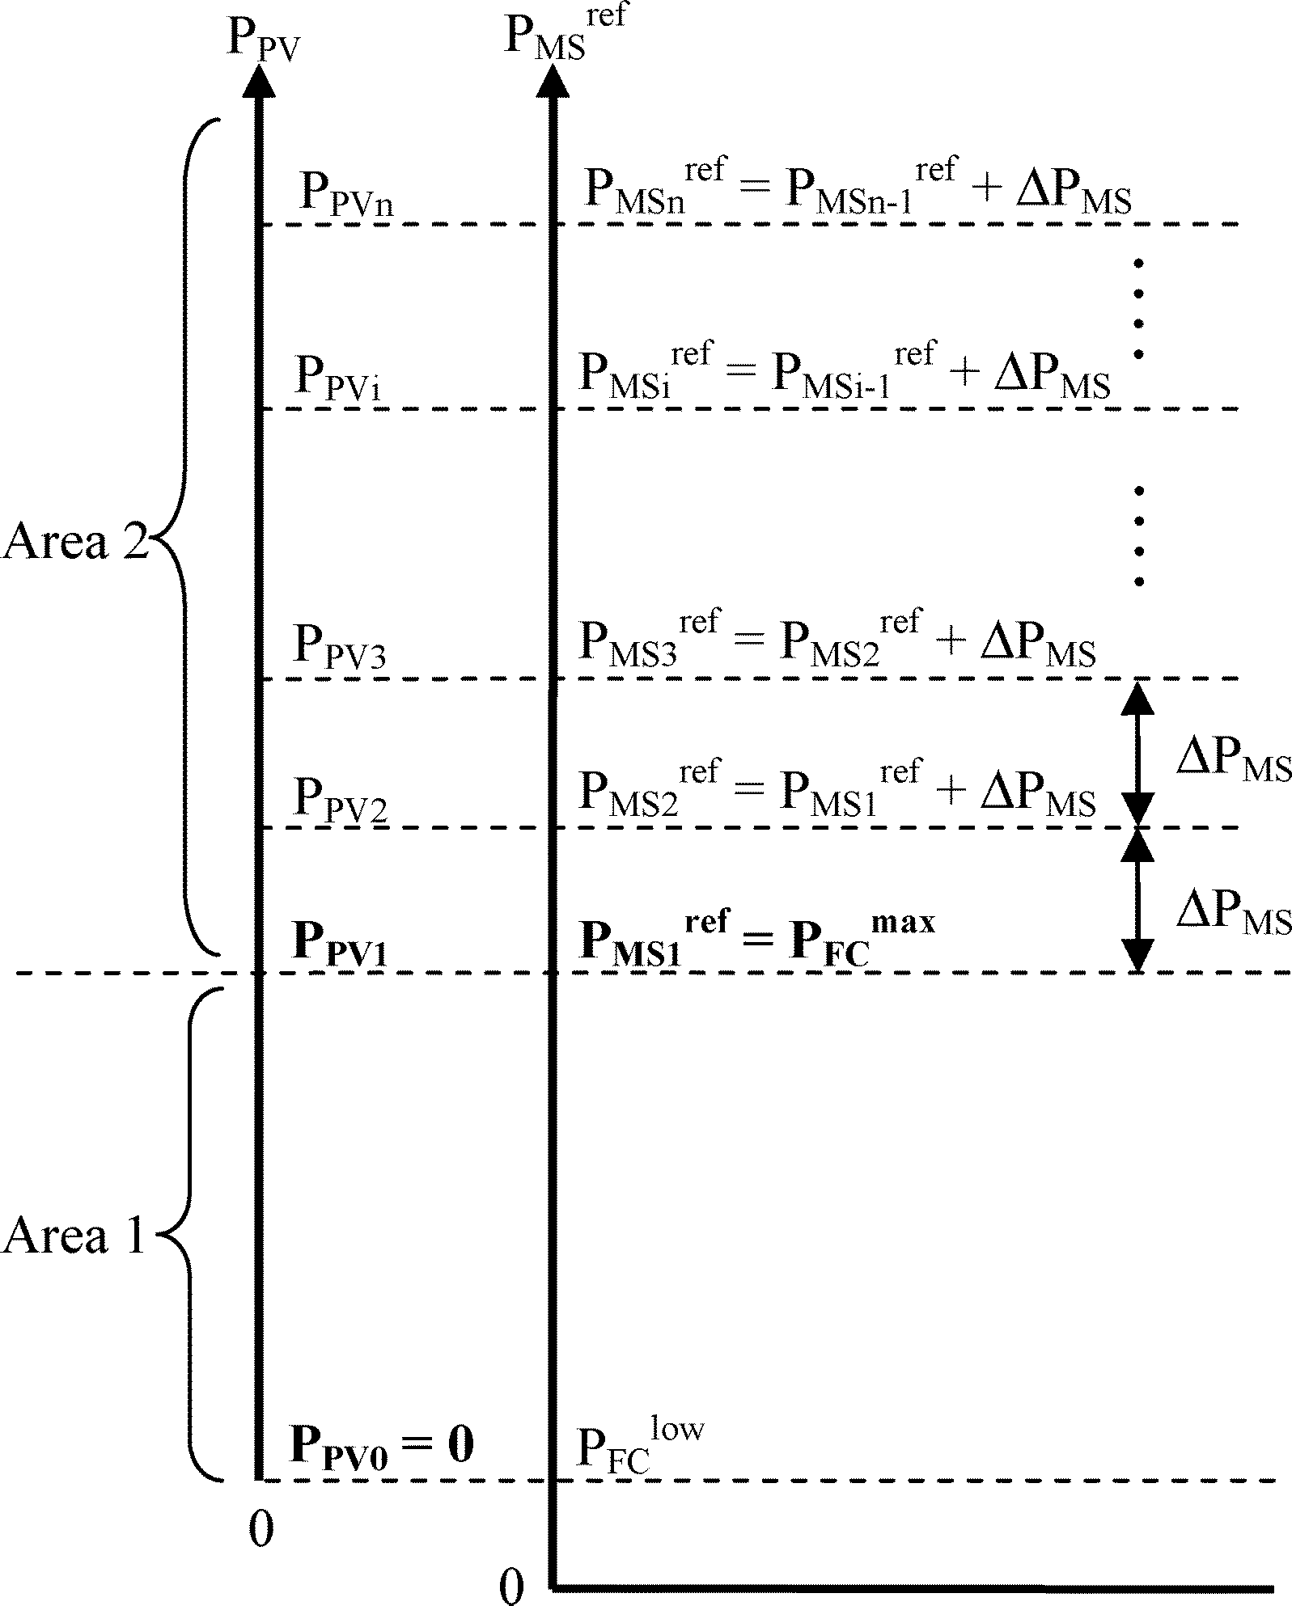
Fig.5.4: Operating strategy of hybrid source in the UPC mode

Once the constraints are known, the control mode of the hybrid source (UPC mode and FFC mode) depends on load variations and the PV output. The control mode is decided by the algorithm shown in Fig. 5.7, Subsection B. In the UPC mode, the reference output power of the hybrid source P^{ref}_{MS} on the PV output and the constraints of the FC output. The algorithm determining P^{ref}_{MS} is presented in Subsection A and is depicted in Fig.5.4.

5.5 Operating Strategy for the Hybrid System in the UPC Mode:
In this subsection, the presented algorithm determines the hybrid source works in the UPC mode. This algorithm allows the PV to work at its maximum power point, and the FC to work within its high efficiency band. In the UPC mode, the hybrid source P^{ref}_{MS} regulates the output to the reference value. Then
P_{PV} + P_{FC} = P^{ref}_{MS} (11)
Equation (11) shows that the variations of the PV output will be compensated for by the FC power and, thus, the total power will be regulated to the reference value.
However, the FC output must satisfy its constraints and, hence, P^{ref}_{MS} must set at an appropriate value. Fig.5.4 shows the operation strategy of the hybrid source in UPC mode to determine P^{ref}_{MS}. The algorithm includes two areas: Area 1 and Area 2.
In Area 1, P_{PV} is less than P_{PV} , and then the reference Power P^{ref}_{MS1} is set at P^{up}_{FC} where
P_{PV1} = P^{up}_{FC} - P^{low}_{FC} (12)
P^{ref}_{MS1}= P^{up}_{FC} (13)
If PV output is zero, then (11) deduces P_{FC} to be equal to P^{up}_{FC}. If the PV output increases to P_{PV1}, then from (11) and (12), we obtain P_{FC} equal to P^{low}_{FC}. In other words, when the PV output varies from zero to P_{PV1}, the FC output will change from P^{up}_{FC} to P^{low}_{FC}. As a result, the constraints for the FC output always reach Area 1. It is noted that the reference power of the hybrid source during the UPC mode is fixed at a constant P^{up}_{FC}. Area 2 is for the case in which PV output power is greater than P_{PV1}. As examined earlier, when the PV output increases to P_{PV1}, the FC output will decrease to its lower limit P^{low}_{FC}. If PV output keeps increasing, the FC output will decrease below its limit P^{low}_{FC}.
In this case, to operate the PV at its maximum power point and the FC within its limit, the reference power must be increased. As depicted in Fig. 5.4, if PV output is larger than P_{PV1}, the reference power will be increased by the amount of ∆P_{MS}, and we obtain
P^{ref}_{MS2} = P_{PV1} + ∆P_{MS} (14)
Similarly, if P_{PV} is greater than P_{PV2}, the FC output becomes less than its lower limit and the reference power will be thus increased by the amount of ∆P_{MS} . In other words, the reference
power remains unchanged and equal to P^{ref}_{MS2} if is less than P_{PV2} and greater than P_{PV1} where
P_{PV2} = P_{PV1} + ∆P_{MS} (15)
it is noted that ∆P_{MS} is limited so that with the new reference power, the FC output must be
less than its upper limit P^{up}_{FC} . Then, we have
∆P_{MS} ≤ P^{up}_{FC} – P^{low}_{FC} (16)
In general, if the PV output is between P_{PVi} and P_{PVi-1}(i = 2, 3, 4….), then we have
P^{ref}_{MSi} = P^{ref}_{MSi-1} + ∆P_{MS} (17)
P_{PVi} = P_{PVi-1} + ∆P_{MS} (18)
Equations (17) and (18) show the method of finding the reference power when the PV output is in Area 2. The relationship between P^{ref}_{MSi} and P_{PVi} is obtained by using (12), (13), and (18) in (17), and then
P^{ref}_{MSi} = P_{PVi} + P^{min}_{FC}, i = 2, 3, 4…. (19)
The determination of P^{ref}_{MS} in Area 1 and Area 2 can be generalized by starting the index from 1. Therefore, if the PV output is
P_{PVi-1} ≤ P_{PV} ≤ P_{PVi}, i = 1, 2, 3…..
then we have
P^{ref}_{MSi} = P_{PVi} + P^{min}_{FC}, i = 1, 2, 3….. (20)
P_{PVi} = P_{PVi-1} + ∆P_{MS}, i = 2, 3, 4……. (21)
it is noted that when i = 1, P_{PV1} is given in (12), and
P_{PVi-1} = P_{PV0} = 0 (22)
In brief, the reference power of the hybrid source is determined according to the PV output power. If the PV output is in Area 1, the reference power will always be constant and set at P^{up}_{FC}. Otherwise, the reference value will be changed by the amount of ∆P_{MS}, according to the change of PV power.
The reference power of the hybrid source in Area 1 and Area 2 is determined by (20) and (21). P_{PV0,} P_{PV1,} and ∆P_{MS} are shown in (22), (12), and (16), respectively. Fig.5.5. shows the control algorithm diagram for determining the reference power automatically. The constant C must satisfy (16). If C increases the number of change of P^{ref}_{MS} will decrease and thus the performance of system operation will be improved.

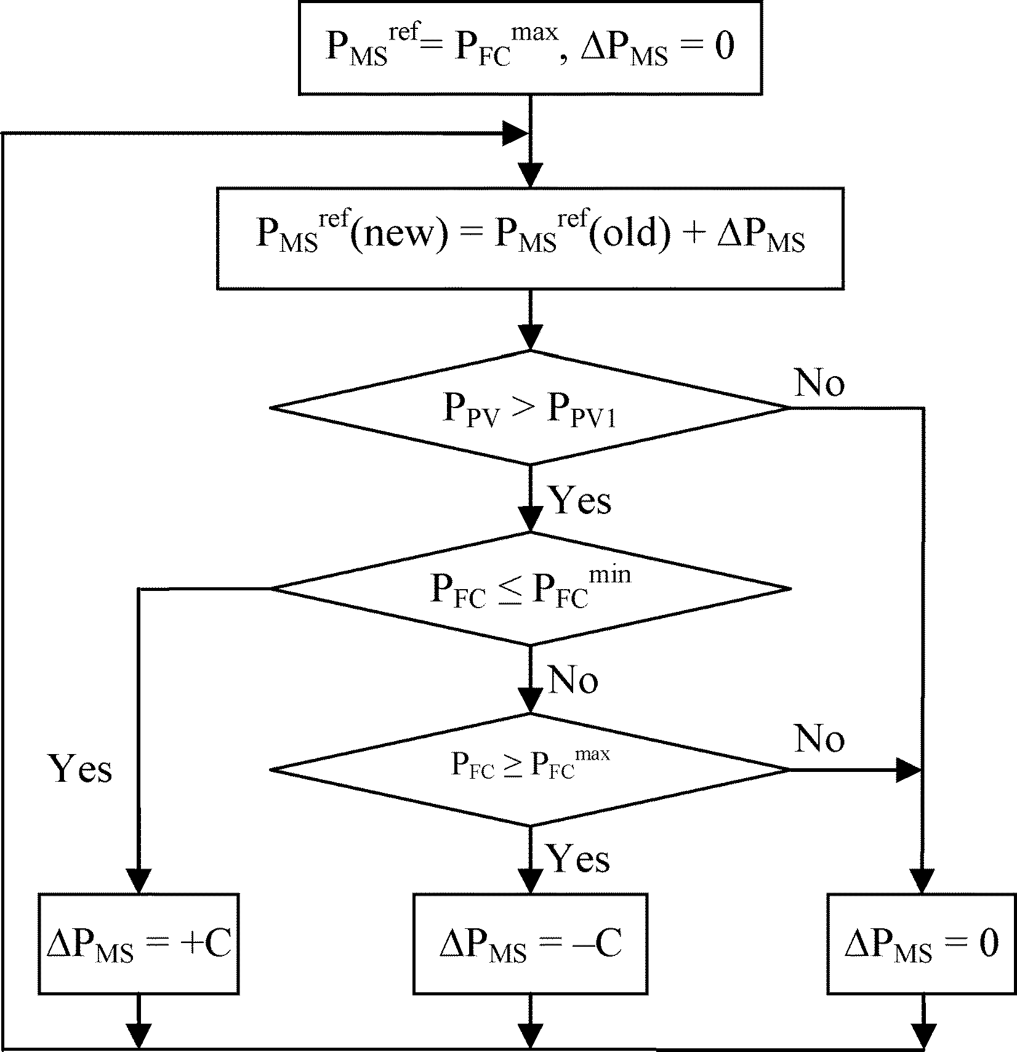
(Fig. 5.5: Control algorithm diagram in the UPC mode
However, C should be small enough so that the frequency does not change over its limits 5%). In order to improve the performance of the algorithm, a hysteresis is included in the simulation model. The hysteresis is used to prevent oscillation of the setting value of the hybrid system reference power P^{ref}_{MS}. At the boundary of change in P^{ref}_{MS}, the reference value will be changed continuously due to the oscillations in PV maximum power tracking. To avoid the oscillations around the boundary, a hysteresis is included and its control scheme to control P^{ref}_{MS} is depicted in Fig.5.6.
5.6 Overall Operating Strategy for the Grid-Connected Hybrid System:
It is well known that in the microgrid, each DG as well as the hybrid source has two control modes: 1) the UPC mode and 2) the FFC mode.
In the aforementioned subsection, a method to determine P^{ref}_{MS} in the UPC mode is proposed. In this subsection, an operating strategy is presented to coordinate the two control modes. The purpose of the algorithm is to decide when each control mode is applied and to determine the reference value of the feeder flow when the FFC mode is used.This operating strategy must enable the PV to work at its maximum power point, FC output, and feeder flow to satisfy their constraints. If the hybrid source works in the UPC mode, the hybrid output is regulated to a reference value and the variations in load are matched by feeder power. With the reference power P^{ref}_{MS} proposed in Subsection A, the constraints of FC and PV are always satisfied. Therefore, only the constraint of feeder flow is considered. On the other hand, when the hybrid works in the FFC mode, the feeder flow is controlled to a reference value P^{ref}_{MS} and, thus,
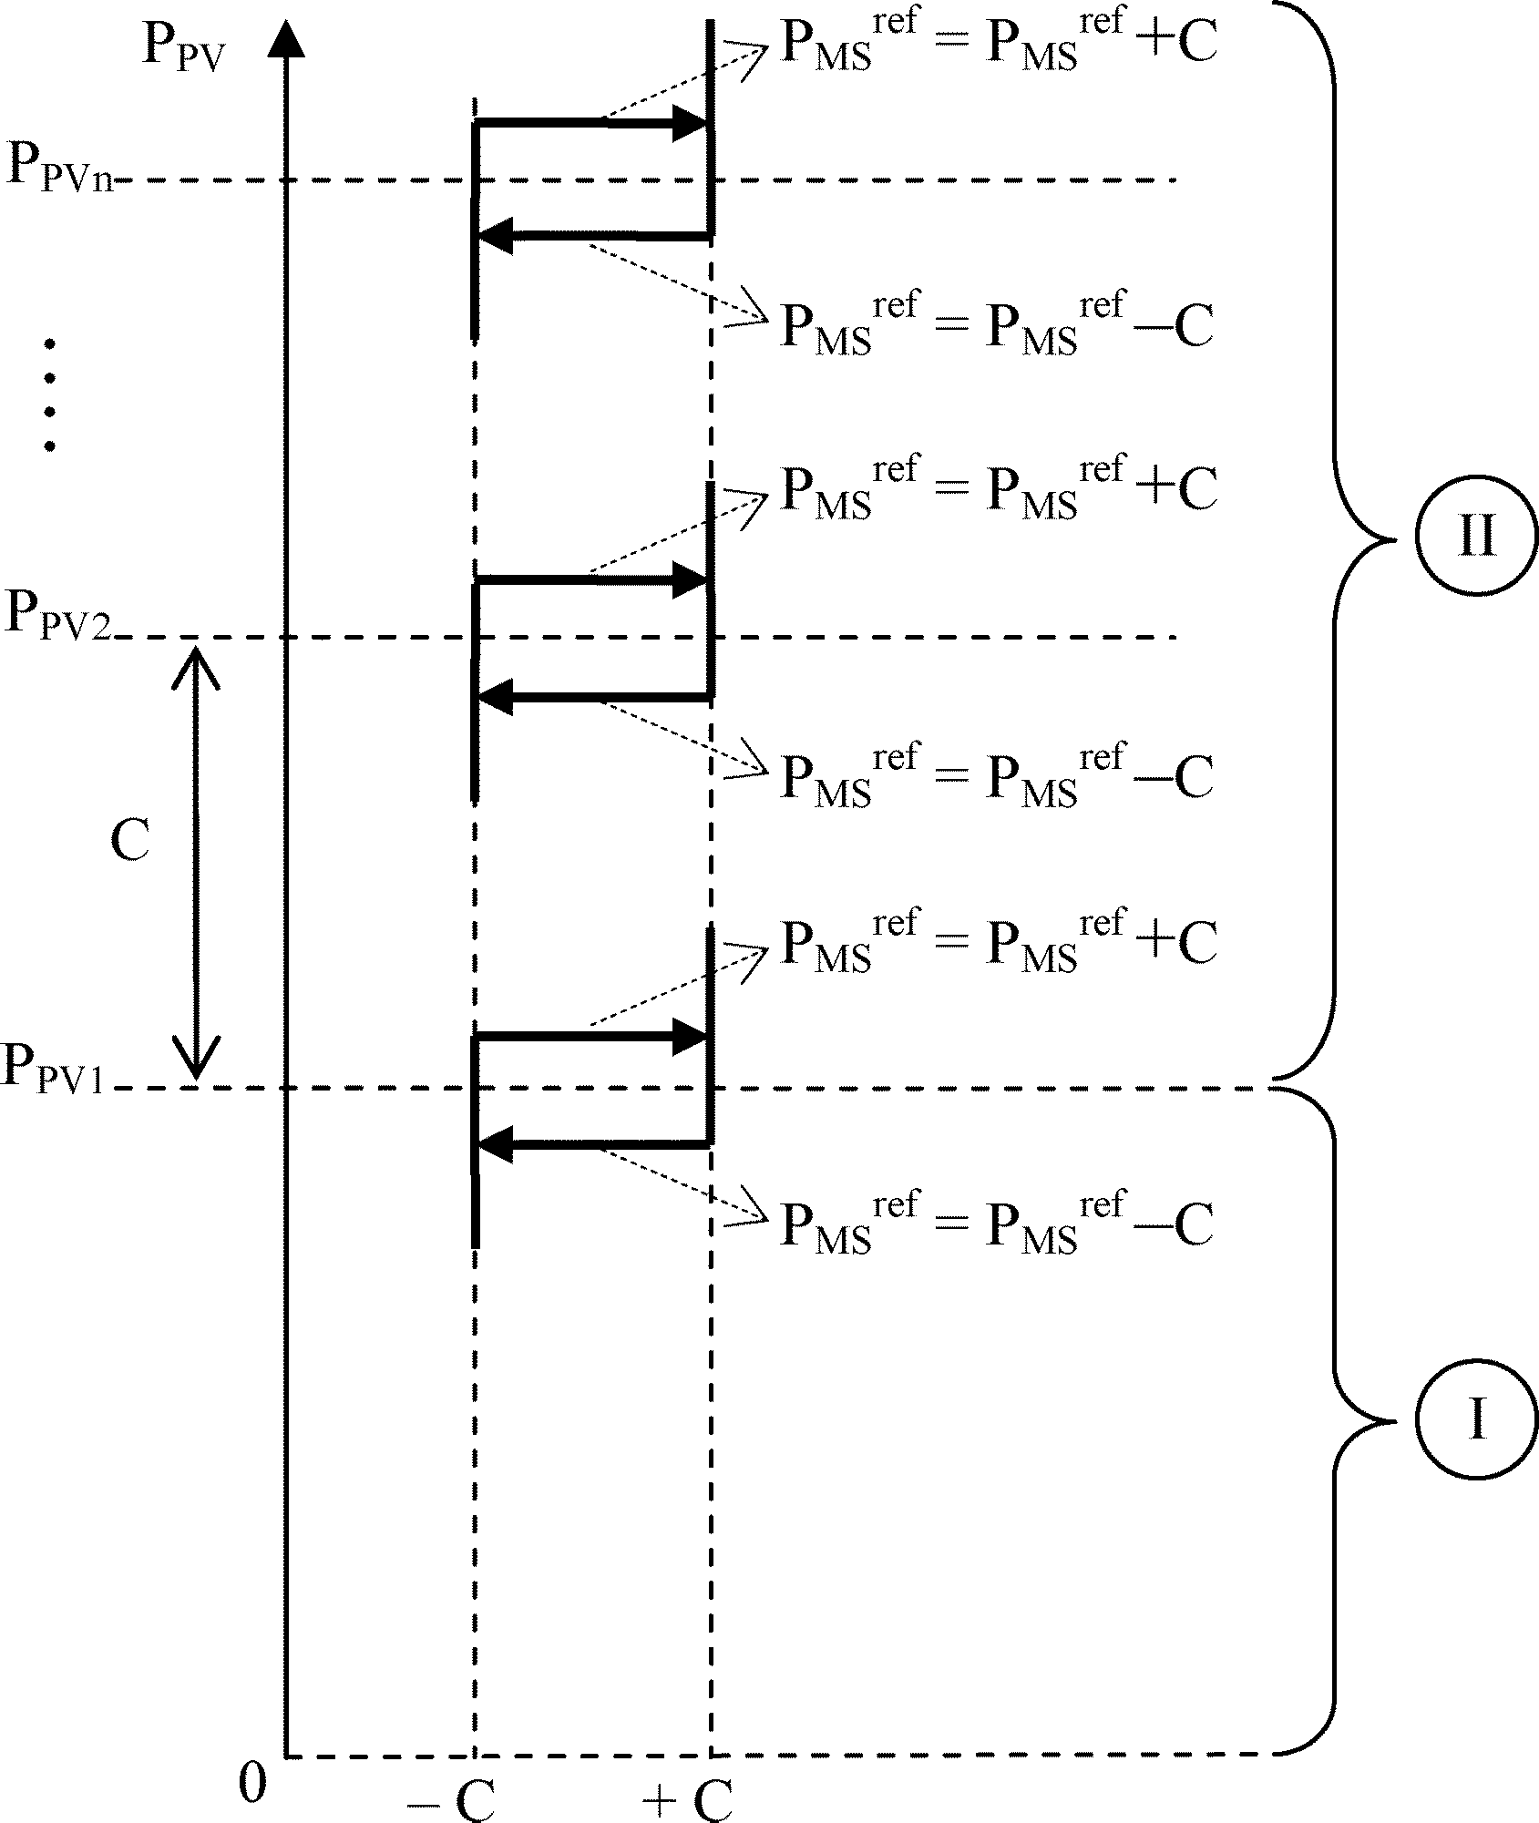
Fig 5.6: Hysteresis control scheme for P^{ref}_{MS} control
the hybrid source will compensate for the load variations. In this case, all constraints must be considered in the operating algorithm. Based on those analyses, the operating strategy of the system is proposed as demonstrated in Fig.5.7. The operation algorithm in Fig. 5.7 involves two areas (Area I and Area II) and the control mode depends on the load power. If load is in Area I, the UPC mode is selected. Otherwise, the FFC mode is applied with respect to Area II. In the UPC area, the hybrid source output is P^{ref}_{MS.} If the load is lower than P^{ref}_{MS}, the redundant power will be transmitted to the main grid. Otherwise, the main grid will send power to the load side to match load demand. When load increases, the feeder flow will increase correspondingly. If feeder flow increases to its maximum P^{max}_{Feeder}, then the feeder flow cannot meet load demand if the load keeps increasing.
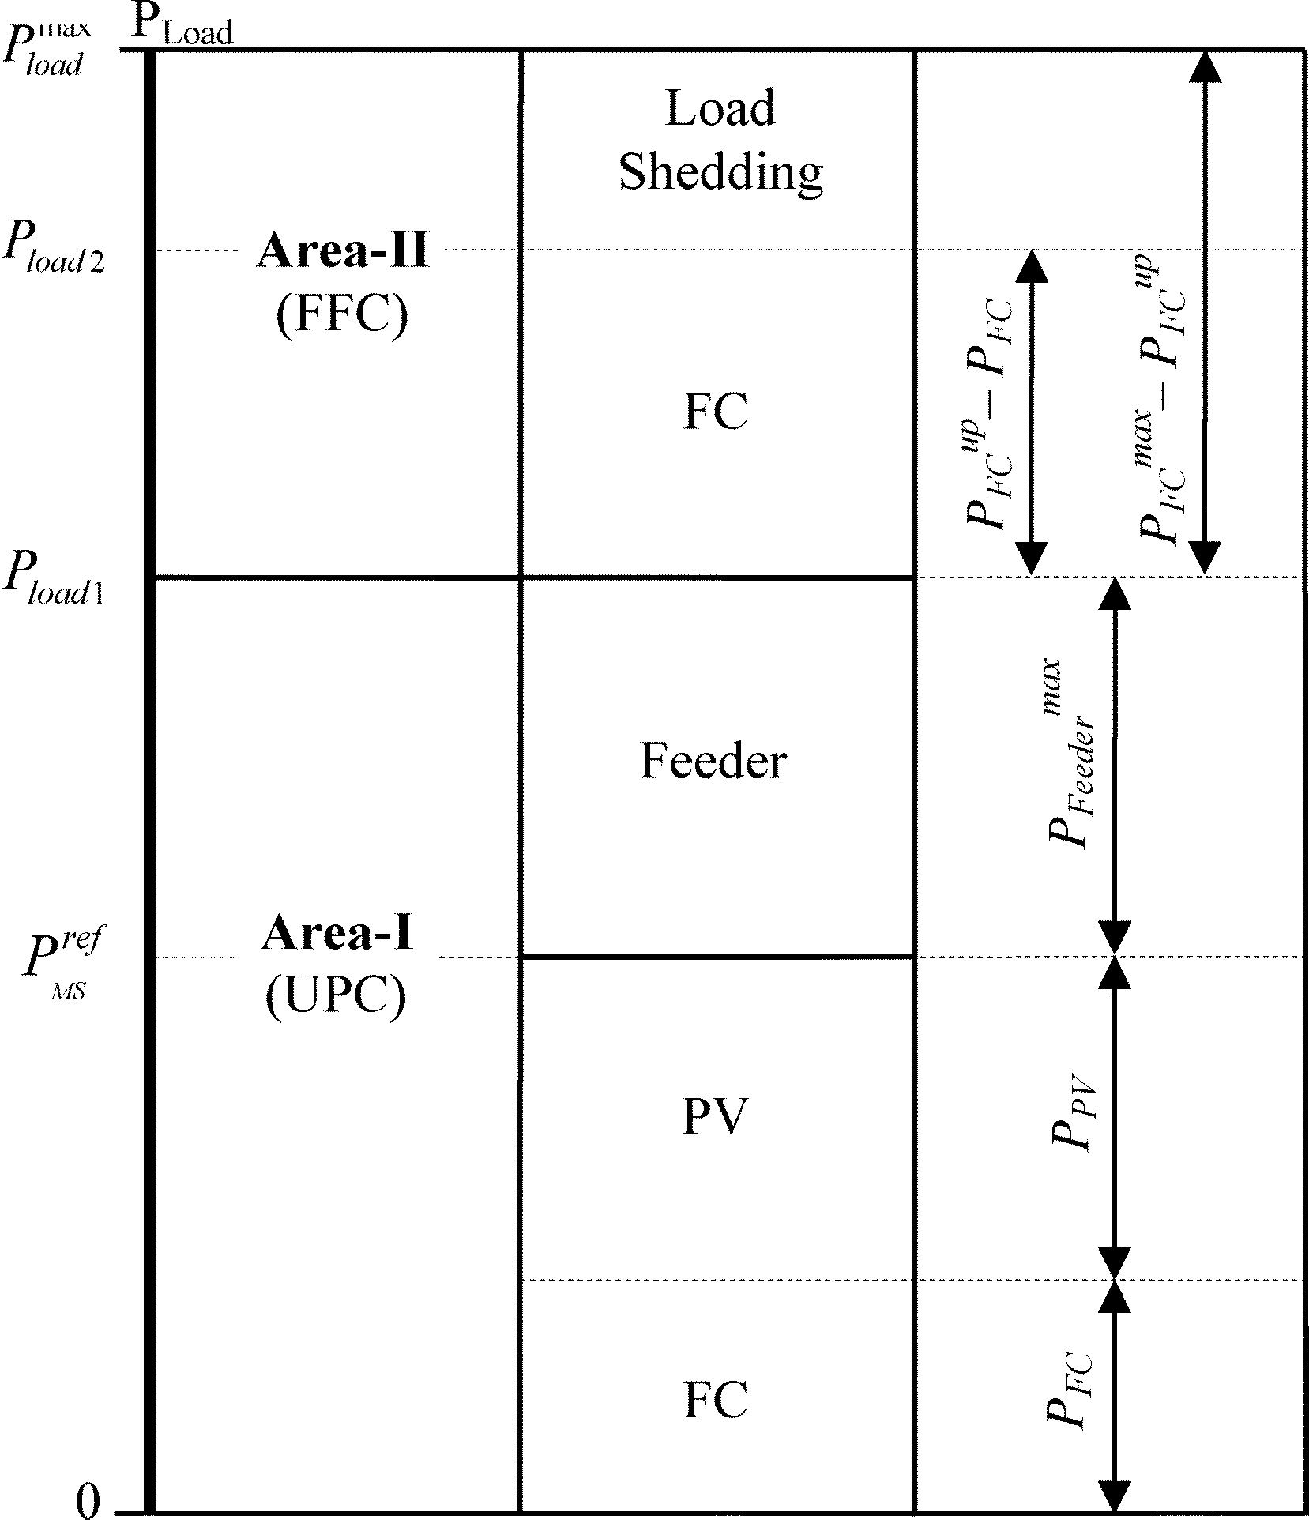
Fig 5.7 Overall operating strategy for the grid-connected hybrid system
In order to compensate for the load demand, the control mode must be changed to FFC with respect to Area II. Thus, the boundary between Area I and Area II P_{Load1} is
P_{Load1} = P^{max}_{Feeder} + P^{ref}_{MS} (23)
When the mode changes to FFC, the feeder flow reference must be determined. In order for the system operation to be seamless, the feeder flow should be unchanged during control mode transition. Accordingly, when the feeder flow reference is set at P^{max}_{Feeder}, then we have
P^{ref}_{Feeder} = P^{max}_{Feeder} (24)
In the FFC area, the variation in load is matched by the hybrid source. In other words, the changes in load and PV output are compensated for by PEMFC power. If the FC output increases to its upper limit and the load is higher than the total generating power, then load shedding will occur. The limit that load shedding will be reached is
P_{Load2} = P^{up}_{FC} + P^{max}_{Feeder} + P_{PV} (25)
Equation (25) shows that P_{Load2} is minimal when PV output is at 0 kW. Then
P^{min}_{Load2} = P^{up}_{FC} + P^{max}_{Feeder} (26)
Equation (26) means that if load demand is less than P^{min}_{Load2}, load shedding will never occur.
From the beginning, FC has always worked in the high efficiency band and FC output has been less than P^{up}_{FC}. If the load is less than P^{min}_{Load2}, load shedding is ensured not to occur. However, in severe conditions, FC should mobilize its availability, P^{max}_{FC,} to supply the load. Thus, the load can be higher and the largest load is
P^{max}_{Load} = P^{max}_{FC} + P^{max}_{Feeder} (27)
If FC power and load demand satisfy (27), load shedding will never occur. Accordingly, based on load forecast, the installed power of FC can be determined by following (27) to avoid load shedding. Corresponding to the FC installed power, the width of Area II is calculated as follows:
P_{Area-II} = P^{max}_{FC} - P^{up}_{FC} (28)
In order for the system to work more stably, the number of mode changes should be decreased. As seen in Fig. 5.7, the limit changing the mode from UPC to FFC is P_{Load1}, which is calculated in (23). Equation (23) shows that P_{Load1} depends on P^{max}_{Feeder} and P^{ref}_{MS}. P^{max}_{Feeder} is a constant,
Thus P_{Load1} depends on P^{ref}_{MS} Fig. 5.4 shows that in Area 2 P^{ref}_{MS} depends on . Therefore, to decrease the number of mode changes, P^{ref}_{MS} changes must be reduced. Thus, ∆P_{MS} must be increased. However

TABLE 5.1
SYSTEM PARAMETERS
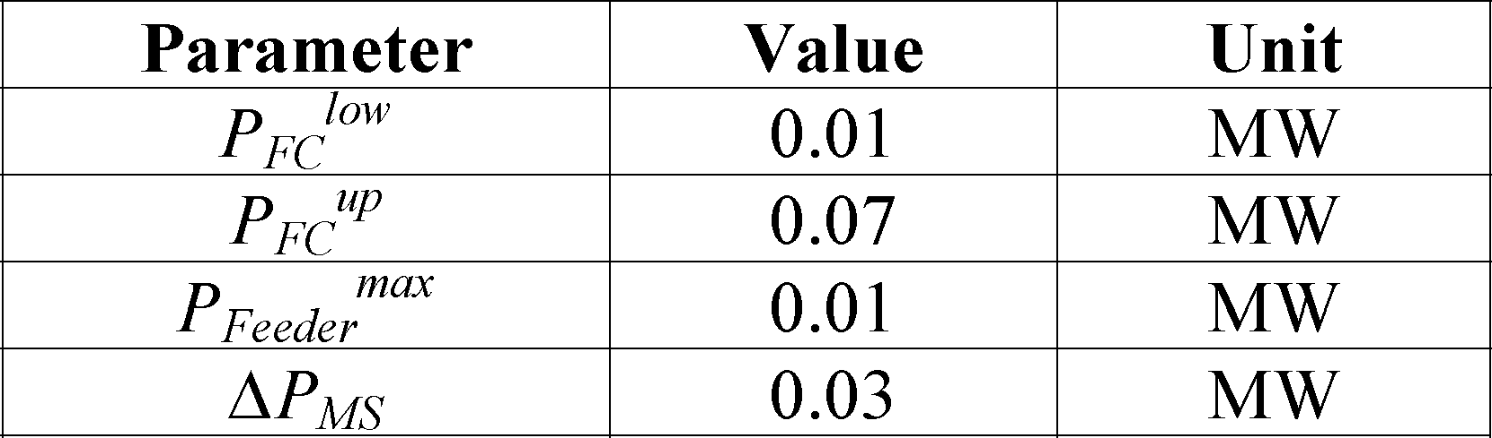
∆P_{MS} must satisfy condition (16) and, thus, the minimized number of mode change is reached when ∆P_{MS} is maximized
∆P^{max}_{MS} = P^{up}_{FC} – P^{low}_{FC} (29)
In summary, in a light-load condition, the hybrid source works in UPC mode, the hybrid source regulates output power to the reference value P^{ref}_{MS}, and the main grid compensates for load variations. P^{ref}_{MS} is determined by the algorithm shown in Fig. 4 and, thus, the PV always works at its maximum power point and the PEMFC always works within the high efficiency band (P^{low}_{FC} – P^{up}_{FC}). In heavy load conditions, the control mode changes to FFC, and the variation of load will be matched by the hybrid source. In this mode, PV still works with the MPPT control, and PEMFC operates within its efficiency band until load increases to a very high point. Hence, FC only works outside the high efficiency band (P^{up}_{FC} – P^{max}_{FC}) in severe conditions. With an installed power of FC and load demand satisfying (27), load shedding will not occur. Besides, to reduce the number of mode changes, ∆P_{MS} must be increased and, hence, the number of mode changes is minimized when ∆P_{MS} is maximized, as shown in (29).

6. MATLAB DESIGN OF CASE STUDY AND RESULTS Simulation Model Case I: Grid connected PV-FC Hybrid system

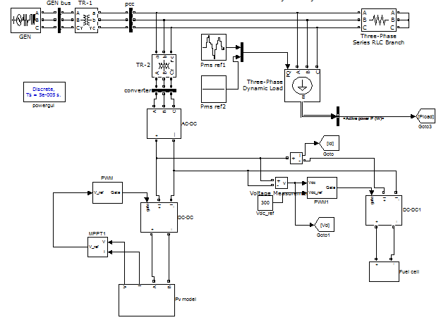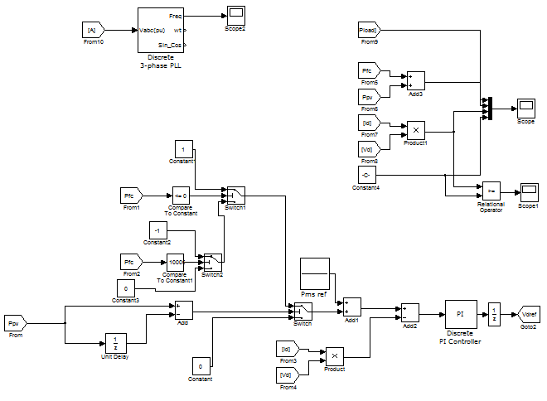

Fig 6.1: Grid connected PV-FC hybrid system

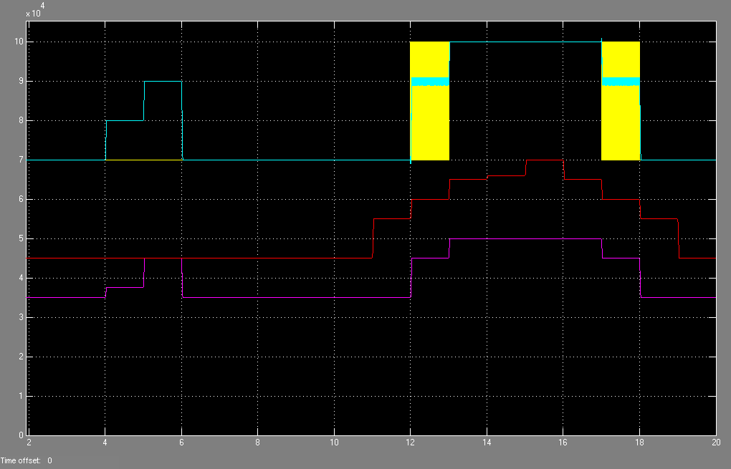

Fig.6.2: Operating strategy of the hybrid source without hysteresis control

Simulation Model Case II:

Fig: Grid connected PV-FC hybrid system

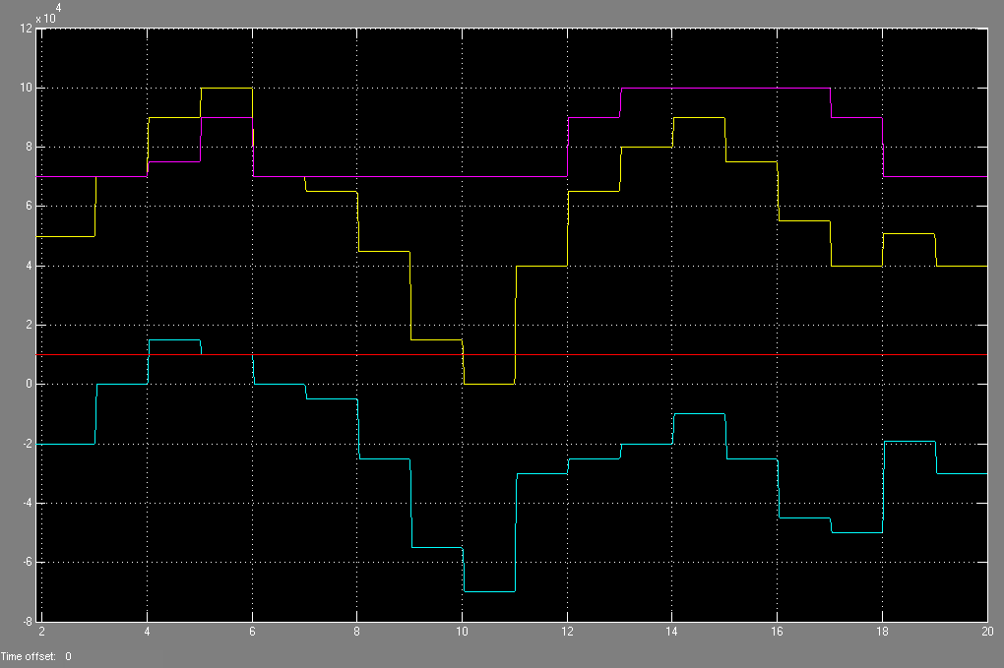
Fig.6.3: Operating strategy of the whole system without hysteresis control
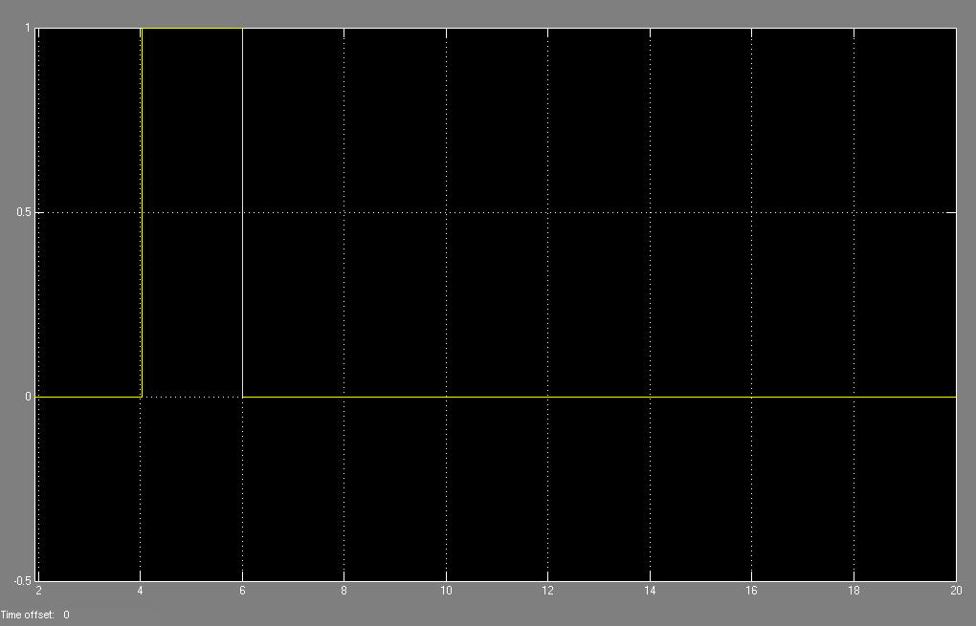
Fig.6.4: Change of operating modes without hysteresis.

Simulation Model Case III:

Fig . Grid connected PV-FC hybrid system

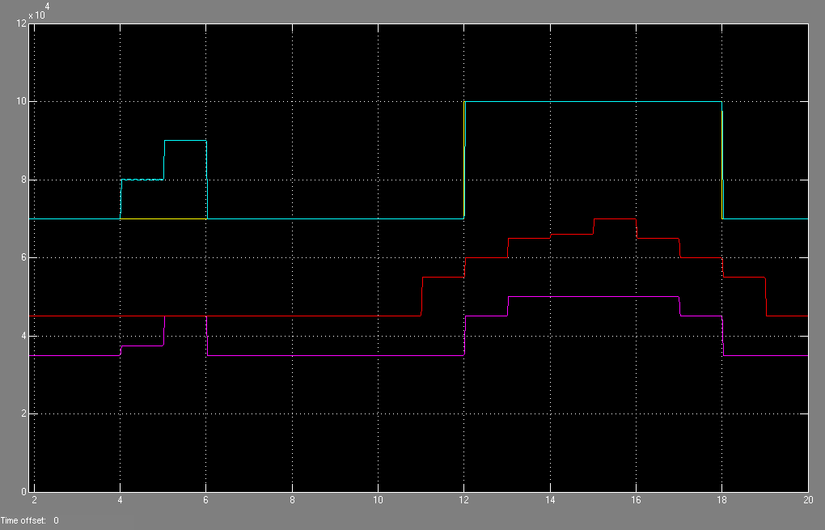

Fig.6.5: The operating strategy of the hybrid source with hysteresis

Simulation Model Case IV:

Fig: Grid connected PV-FC hybrid system
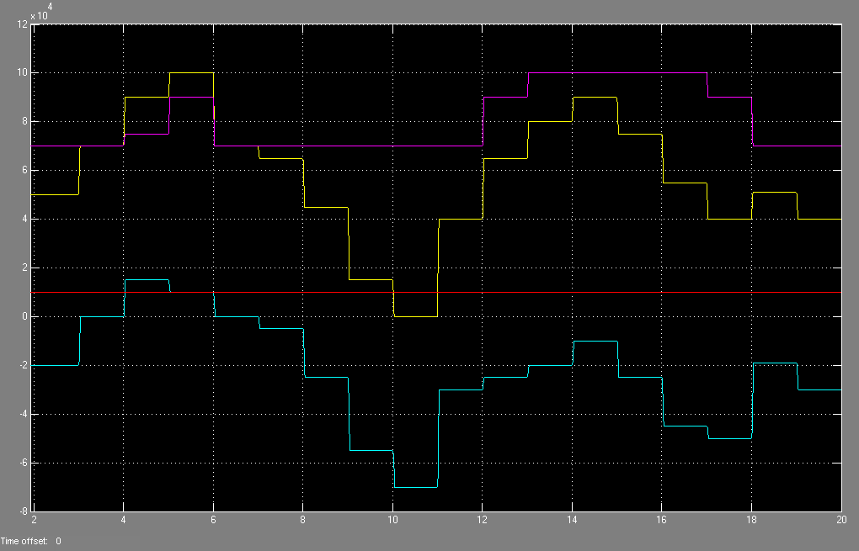
Fig: 6.6: Operating strategy of the whole system with hysteresis
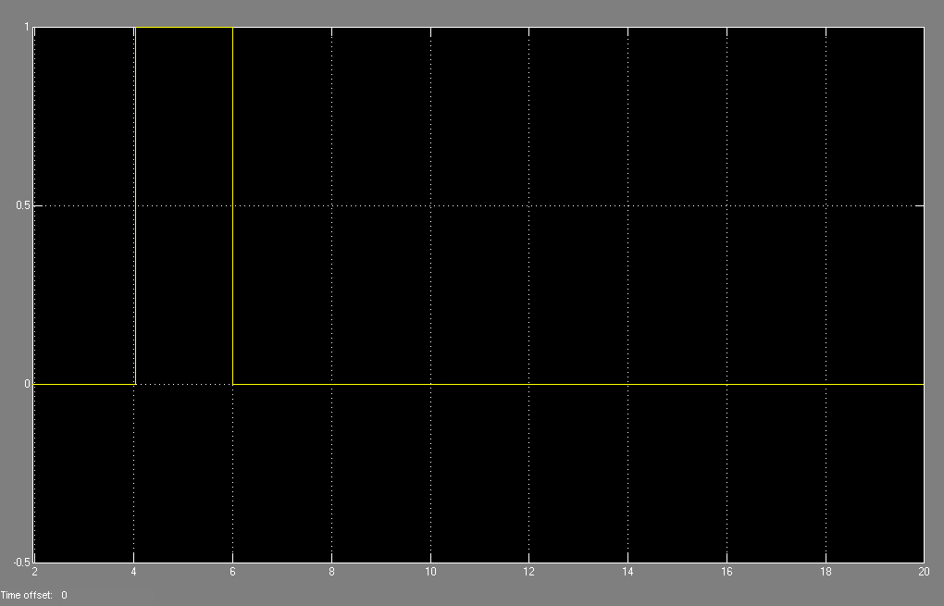
Fig 6.7: Change of operating modes with hysteresis

7. CONCLUSIONS
- This paper has presented an available method to operate a hybrid grid-connected system.
- The hybrid system, composed of a PV array and PEMFC, was considered successfully.
- The operating strategy of the system has coordinated PV array and PEMFC effectively based on the two modes of UPC mode and FFC mode.
- The proposed operating strategy presented in this paper well aimed to determine the control mode, to minimize the number of mode changes, to operate PV at the maximum power point, and to operate the FC output in its high-efficiency performance band.

8. FUTURE SCOPE
“Hybrid systems playing a major role”

In future, if we have an involuntary deficient of Conventional energy resources of Coal, Diesel, etc., then generation of electrical power through Hybrid systems consisting of Solar plant, Fuel cell, wind turbine or any other Non-Conventional energy resource would play a major role which would be more economical if the Operating strategies are well co-ordinated with the energy resources.

REFERENCES:
[1] T. Bocklisch, W. Schufft, and S. Bocklisch, “Predictive and optimizing energy management of photovoltaic fuel cell hybrid systems with short time energy storage,” in Proc. 4th Eur. Conf. PV-Hybrid and Mini- Grid, 2008, pp. 8–15.
[2] J. Larmine and A. Dicks, Fuel Cell Systems Explained. New York: Wiley, 2003.
[3] W. Xiao, W. Dunford, and A. Capel, “A novel modeling method for photovoltaic cells,” in Proc. IEEE 35th Annu. Power Electronics Specialists Conf., Jun. 2004, vol. 3, pp. 1950–1956.
[4] D. Sera, R. Teodorescu, and P. Rodriguez, “PV panel model based on datasheet values,” in Proc. IEEE Int. Symp. Industrial Electronics, Jun. 4–7, 2007, pp. 2392–2396.
[5] C. Wang, M. H. Nehrir, and S. R. Shaw, “Dynamic models and model validation for PEM fuel cells using electrical circuits,” IEEE Trans. Energy Convers., vol. 20, no. 2, pp. 442–451, Jun. 2005.
[6] C. Hua and C. Shen, “Comparative study of peak power tracking techniques for solar storage system,” in Proc. 13th Annu. Applied Power Electronics Conf. Expo., Feb. 1998, vol. 2, pp. 679–685.
[7] A. Hajizadeh and M. A. Golkar, “Power flow control of grid-connected fuel cell distributed generation systems,” J. Elect. Eng. Technol., vol. 3, no. 2, pp. 143–151, 2008.
[8] C. Hua and J. R. Lin, “DSP-based controller application in battery storage of photovoltaic system,” in Proc.22nd IEEE Int. Conf. Industrial Electronics, Control, and Instrumentation, Aug. 5–10, 1996, vol. 3, pp. 1750–1810.
[9] C. Hua, J. Lin, and C. Shen, “Implementation of a DSP-controlled photovoltaic system with peak power tracking,” IEEE Trans. Ind. Electron., vol. 45, no. 1, pp. 99–107, Feb. 1998.
BASE PAPER: Loc Nguyen Khangh,Student Member,IEEE,Jae-Jin seo,Yung-seong Kim,and Dong-Jun Won,Member,IEEE D

